

A guide for healthcare
staff self-testing for
coronavirus using a
Lateral Flow Device (LFD)
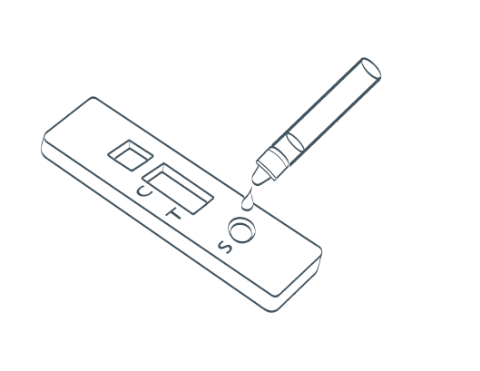
This guide will help you remain well at work and keep your patients safe.
This test is suitable for healthcare workers.

About this test kit
This test is part of the government’s response to the pandemic and its commitment to controlling infection and supporting our healthcare staff.
Please follow the instructions in this booklet as this sets out how the test can be self-administered.

Overview

Here is a quick checklist for how to use the COVID-19 LFD tests. It is really important that you follow these steps in the correct order.
You should test yourself twice a week before your shift, every 3 to 4 days, to fit your shift pattern – for example, every Monday and Thursday or Wednesday and Sunday.

- Ordering your test kit
- Prepare your test area and unpack your equipment
- Take your swab sample
- Process your sample and wait 30 minutes
- Read your result
- Report your result
- Safely dispose of test equipment
If you receive a positive test, you must immediately report the result to your
Line manager who will then need to complete a self-isolation form. See Trust guidelines here: https://covid.sthk.nhs.uk/self-isolation-guidance/ (password: STHKcovid19)

You will be asked to take a confirmatory PCR test.

If your PCR test is positive you DO NOT need to self-test using the LFD for 90 days, from the date you became positive.
Remember, store the test kit at room temperature – not in direct sunlight and
not in a fridge or freezer. Keep the test kit away from children.

Ordering a Test Kit

The Trust no longer supplies LFD kits to staff for routine testing but they can be ordered via the government website at:
https://www.gov.uk/order-coronavirus-rapid-lateral-flow-tests
When ordering please ensure you answer the following questions:
- Do you work for the NHS in England and take part in their staff testing programme? Yes
- Select the area you work. Acute (hospital) trust
- What’s the name of the NHS trust? St Helens & Knowsley Teaching Hospitals NHS Trust
Test kits usually take 24 hours to arrive.

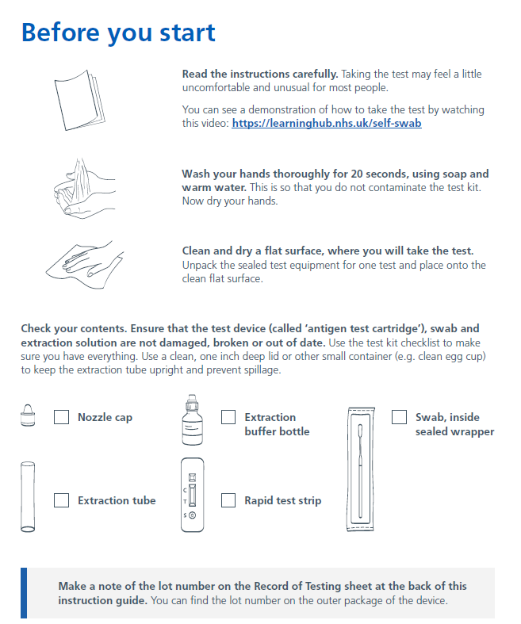

Something damaged/broken/missing? If you have difficulties using the kit, if something breaks or is damaged in use or if you have concerns about the performance of the test, report these issues to your Matron. Any problems or concerns with this device can also be reported to MHRA
https://coronavirus-yellowcard.mhra.gov.uk/about

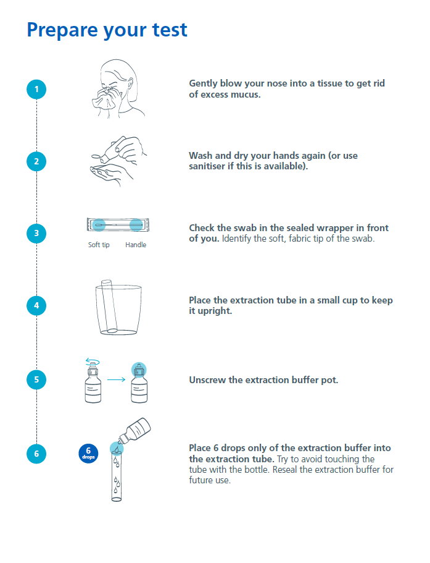

Take your sample

Please read over the manufacturer’s guidance on collecting your sample. Some kits require a nose and throat swab but others may only require a nose swab.
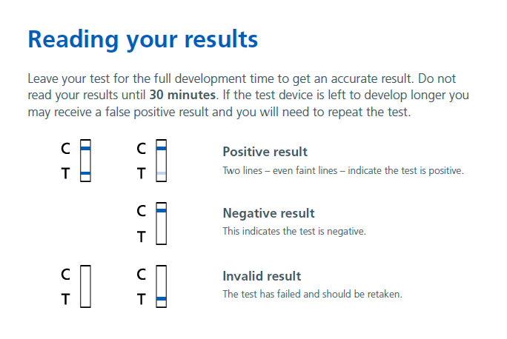
Reporting your results
You must report your results on the reporting system via government website:

https://www.gov.uk/report-covid19-result
If your test result is POSITIVE

Staff undertaking regular Lateral Flow Device testing (LFD), who test positive but are well (asymptomatic) should self-isolate and inform their line manager immediately. The line manager must refer the staff member to the Self-Isolation Team, however, the staff member does not need confirmation via a PCR test.

The staff member must send photographic proof of the positive LFD test to their line manager, including the serial number of the test, and this must be forwarded on to the Self-Isolation Team for recording.

Self-isolation guidelines: https://covid.sthk.nhs.uk/self-isolation-guidance/ (password: STHKcovid19)

If your test result is NEGATIVE

Record the information on the report system.
If your test result is INVALID
Record the information on the reporting system and repeat the test with a new test kit.

If you have coronavirus (COVID-19) symptoms please refer to the Trust’s self-isolation guidance: https://covid.sthk.nhs.uk/self-isolation-guidance/ (password: STHKcovid19) as this test may miss some positive cases.

Disposing of your test
Carefully dispose of the test device and equipment.

Need more help?

Coronavirus guidance and help: If you have coronavirus (COVID-19) symptoms or have contracted coronavirus (COVID-19), please refer to the Trust’s covid website for more guidance: https://covid.sthk.nhs.uk/ (password: STHKcovid19)

If you have symptoms of coronavirus (COVID-19) and your condition gets worse, or you
do not get better after 7 days, use the NHS 111 online coronavirus service, 111.nhs.uk.
If you do not have internet access, call NHS 111. For a medical emergency dial 999.

Do not delay getting help if you are worried. Trust your instincts.

We are working with NHS Test and Trace to collect safety and performance data during
the roll out of COVID-19 testing initiatives. Problems with this device can be reported
directly to MHRA https://coronavirus-yellowcard.mhra.gov.uk/

