**Guidance on the use of Non Invasive Ventilation (NIV) and High flow Oxygen (HFO (Airvo)) in the context of COVID-19 and severe ventilatory failure.**

Aerosols generated by medical procedures are one route for the transmission of the COVID-19 virus. Both the use of **NIV/CPAP** and **HFO** are considered aerosol generating procedures. Use of these modalities clearly has implications for infection control and outcome. These modalities can **ONLY** be provided in an enclosed space in ED or in the NIV/CPAP area of the Respiratory Department where all staff are wearing **enhanced PPE including FFP3 mask.**

Ward based NIV/CPAP will continue to be provided to those patients where Critical care is NOT appropriate and the ceiling of treatment will be NIV/CPAP. e.g. patients with Chronic Obstructive Pulmonary disease or neuromuscular weakness.

**NIV/CPAP will NOT be initiated in any patient unless,**

* Appropriate COVID-19 swabs have been taken.
* The ceiling of care of NIV/CPAP is clearly documented.
* The CPR status of the patient is appropriately documented in the case notes.

**Once COVID-19 swab result is available two pathways will emerge.**

**Overall management will be governed by performance status and whether the patient is a candidate for critical care**. The Clinical Frailty Scale (CFS) should be used in patients over 65 with no stable long term disability or autism. An individualised assessment for patients under 65 or any age with long term disability, learning disabilities or autism, should be used.

If a patient’s clinical frailty is deemed 5 or more (or equivalent) then they will be deemed NOT for ITU. The ceiling of treatment will therefore be ward based treatment with maximum oxygenation via face mask with reservoir bag OR NIV/CPAP/HFO in an appropriate enclosed environment (Respiratory NIV/CPAP area) as guided by the Respiratory physicians.

* NOT for CPR must clearly be documented in the case notes.

If a patient’s clinical frailty is deemed 4 or less (or equivalent) they would be considered a candidate for ITU. Critical care assessment should occur as quickly as practically possible.

* In the event that the patient is unsuitable for critical care, the reasons and the limits of any respiratory support, either NIV/CPAP or HFO, must be clearly documented. Not for CPR status must be appropriately documented in the case notes. Palliation as appropriate should be initiated.

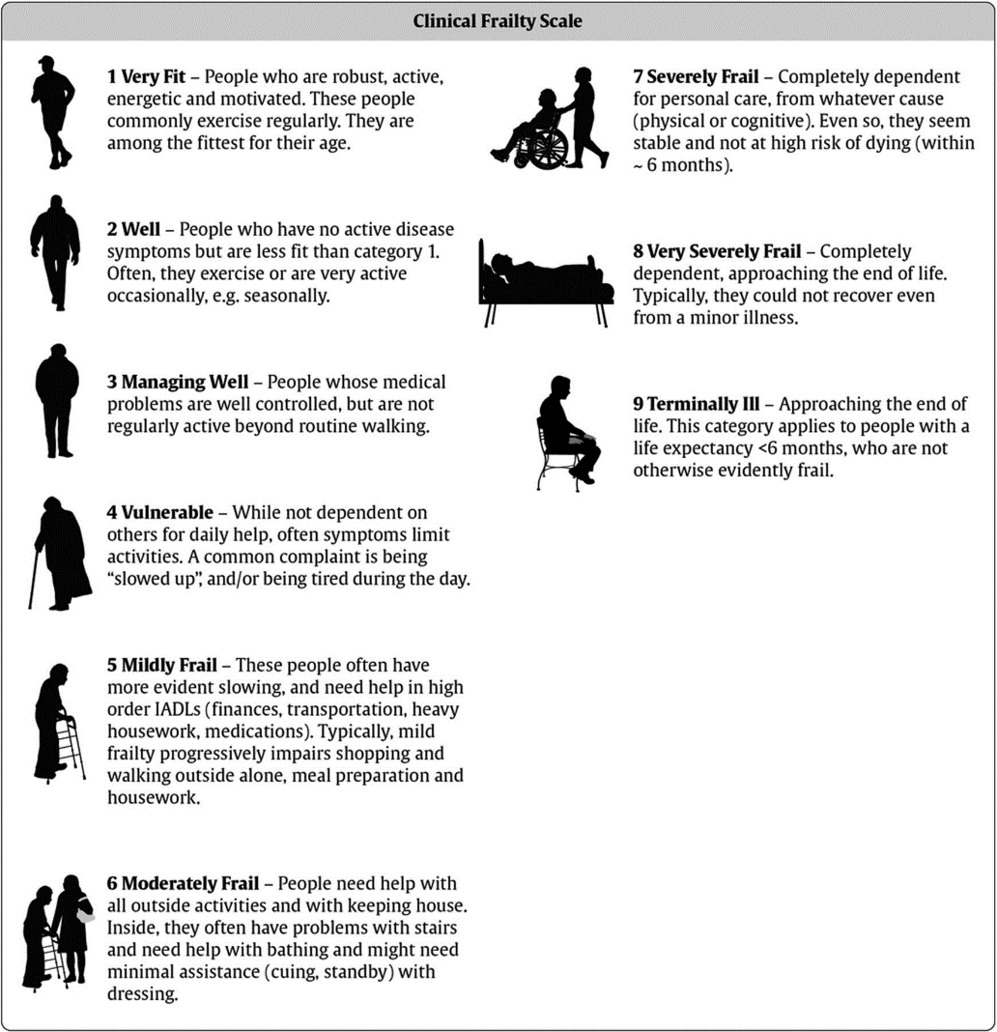

Further considerations.

* All patients with confirmed or strongly suspected COVID-19 infection that require sustained oxygen theapy should be commenced on PO Dexamethasone, with consideration for interleukin-6 receptor binding Mab treatment (Tocilucimab, Sarilumab) – as per national guidance.
* Saline nebs tds/NACSYS 600mg od should be considered in all patients that have suspected or confirmed COVID-19, who require oxygen.
* Patients who normally use home CPAP or NIV/CPAP and are using their own machine whilst in hospital (either prior to COVID 19 testing or are confirmed COVID 19) must:
  + Use an additional filter between the mask and exhaust port which should be changed every 24 hours.
  + Remove any humidification setup – either integral or separate.

**Any NIV/CPAP, including that used in ED, must only be provided in a side room with recommended PPE (for aerosol generating procedures) until such time that the patient is confirmed COVID negative.**

SJT V13 Dec 2021