

A guide for healthcare
staff self-testing for
coronavirus using a
Lateral Flow Device (LFD)
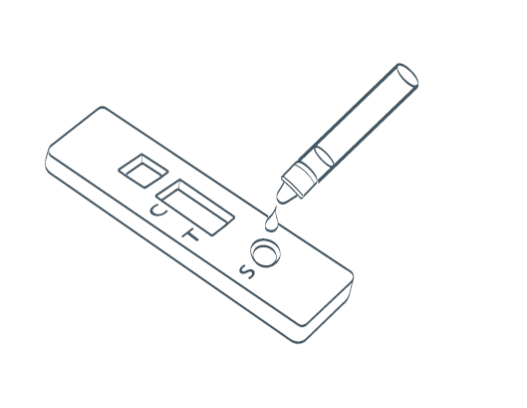
This guide will help you remain well at work and keep your patients safe.
This test is suitable for healthcare workers.

About this test kit
This test is part of the government’s response to the pandemic and its
commitment to controlling infection and supporting our healthcare staff.
Please follow the instructions in this booklet as this sets out how the test can be self-administered.

This has been agreed with experts and the manufacturer has been informed. Other than taking a swab yourself from just inside both nostrils, the process is the same as set out in the manufacturer’s instructions. If you still feel unsure about using this device after receiving training, please contact your Matron.

Overview

Here is a quick checklist for how to use the COVID-19 LFD tests. It is really important that you follow
these steps in the correct order.
You should test yourself twice a week at the end of your shift, every 3 to 4 days, to fit your shift pattern – for example, every Monday and Thursday or Wednesday and Sunday.

- Prepare your test area and unpack your equipment
- Take your swab sample (nasal swab only)
- Process your sample and wait 30 minutes
- Report your result
- Read your result
- Safely dispose of test equipment in the clinical waste
If you receive a positive test, you must immediately report the result to your
Line manager who will then need to complete a self-isolation form. See Trust guidelines here: https://covid.sthk.nhs.uk/self-isolation-guidance/ (password: STHKcovid19)

You will be asked to take a confirmatory PCR test; you and your household should
self-isolate according to HM Government Guidelines until the result of that test is known.

If your PCR test is positive you DO NOT need to self-test using the LFD for 90 days, from the date you became positive.
Remember, store the test kit at room temperature – not in direct sunlight and
not in a fridge or freezer. Keep the test kit away from children.
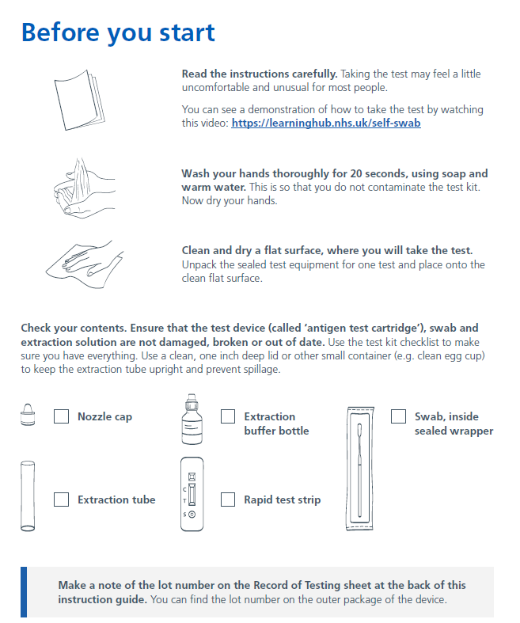

Something damaged/broken/missing? If you have difficulties using the kit, if something breaks or is damaged in use or if you have concerns about the performance of the test, report these issues to your Matron. Any problems or concerns with this device can also be reported to MHRA
https://coronavirus-yellowcard.mhra.gov.uk/about

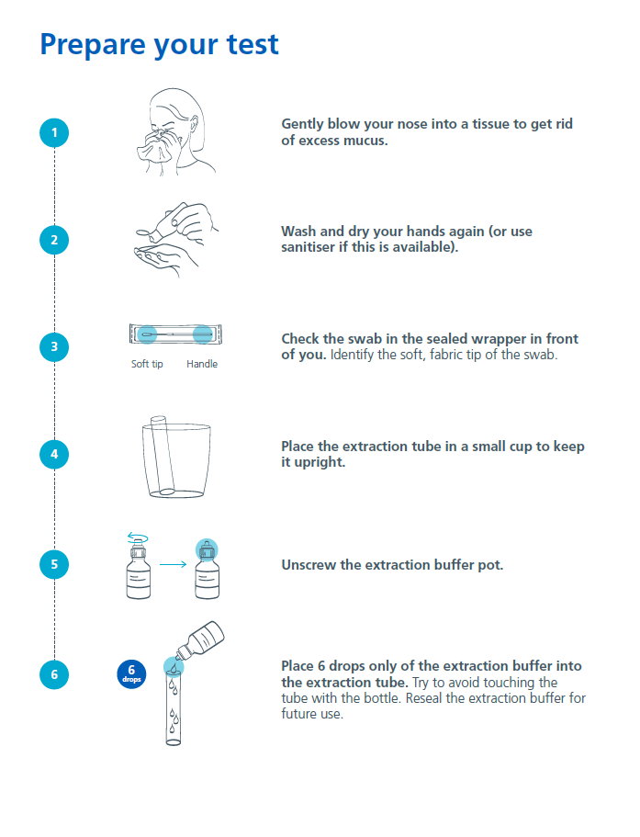

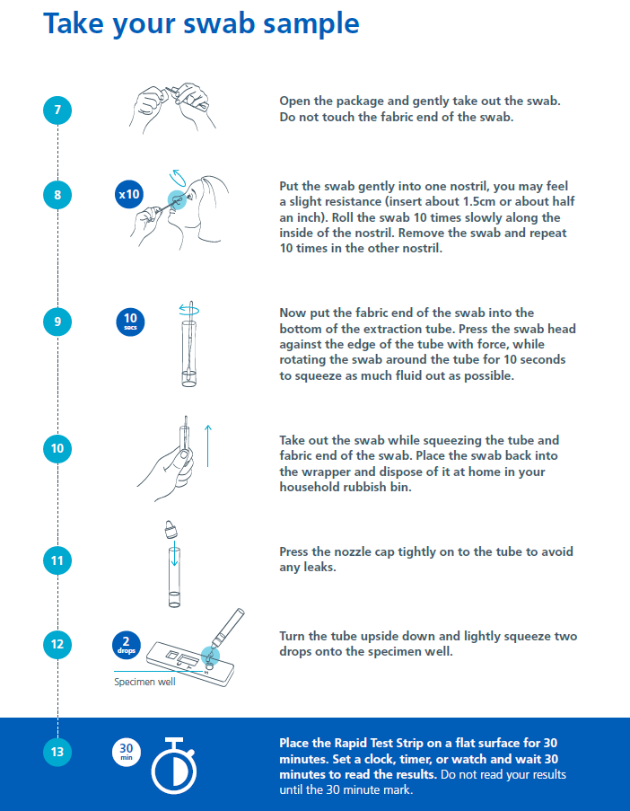

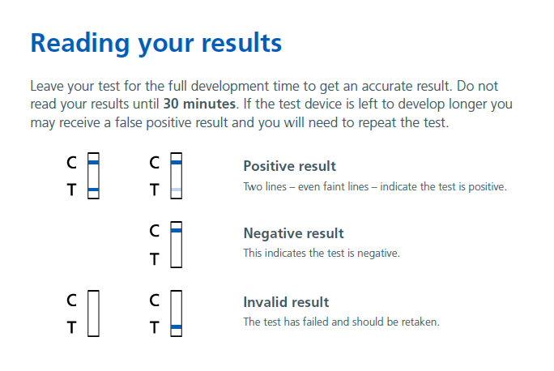
Reporting your results
You must report your results on the reporting system via the below icon on your Trust desktop:


If your test result is positive

You must immediately report your positive test results to your line manager and follow the self-isolation guidelines: https://covid.sthk.nhs.uk/self-isolation-guidance/ (password: STHKcovid19)

If positive, you must take a confirmatory PCR test, this should be done whilst you are still in the department or ward before you leave, and a Self-Isolation form completed by your line manager / the person in charge
Until the results of this test are known, you and your household should self-isolate according to HM Government Guidelines. If your PCR test is positive you DO NOT need to self-test using the LFD for 90 days, from the date you became positive.

If your test result is negative: Record the information on the report system.
If you have coronavirus (COVID-19) symptoms please refer to the Trust’s self-isolation guidance: https://covid.sthk.nhs.uk/self-isolation-guidance/ (password: STHKcovid19) as this test may miss some positive cases.
If your test result is invalid: Record the information on the reporting system and repeat the test with a new test kit.
Disposing of your test
Carefully dispose of the test device and equipment in the clinical waste within your ward/department.

Need more help?

If you need more help using the LFD test kit, contact the Covid Enquiries helpline, Monday to Friday (9-5) 0151 676 5530 or email covidstaff@sthk.nhs.uk

Coronavirus guidance and help: If you have coronavirus (COVID-19) symptoms or have contracted coronavirus (COVID-19), please refer to the Trust’s covid website for more guidance: https://covid.sthk.nhs.uk/ (password: STHKcovid19)

If you have symptoms of coronavirus (COVID-19) and your condition gets worse, or you
do not get better after 7 days, use the NHS 111 online coronavirus service, 111.nhs.uk.
If you do not have internet access, call NHS 111. For a medical emergency dial 999.

Do not delay getting help if you are worried. Trust your instincts.

We are working with NHS Test and Trace to collect safety and performance data during
the roll out of COVID-19 testing initiatives. Problems with this device can be reported
directly to MHRA https://coronavirus-yellowcard.mhra.gov.uk/

