**How to Report Covid-19 Sickness and Isolating Absence in ESR Manager / Supervisor Self Service & Roster**

1 - Open ESR, you will open on your own dashboard page.

2 - Click under “My Role” on the left hand side, select “My ESR" then select “Manager”

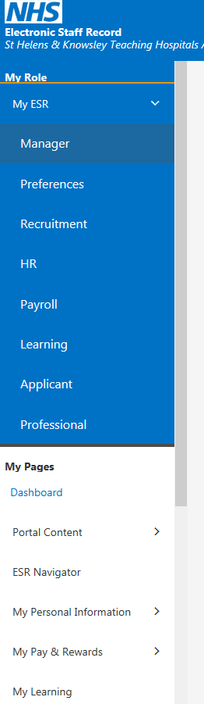

3 - Click on “ESR Navigator”

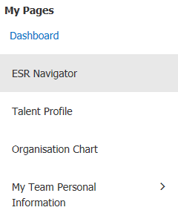

4 - Choose “409 Manager Self Service” or “409 Supervisor Self Service” from the left hand side menu



5 - A menu will appear on the right hand side. Choose “Absence” under “My Team Personal Information”

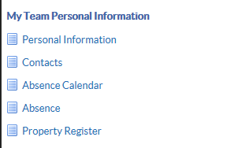

6 - You will be presented with your team in the hierarchy you manage. For the employee you are reporting on, choose the action button at the right hand side of their name.

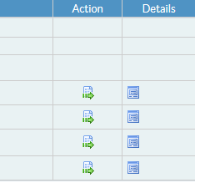

7 - Choose “Create Absence”



8 - Complete the box as below

Absence Type – Sickness

Level 1 Reason – S15 Chest & respiratory problems

Duration – enter start and end date of sickness **(if known and the employee has stated a date they intend to resume. If not leave the end date blank until the resume and update once they have returned)**

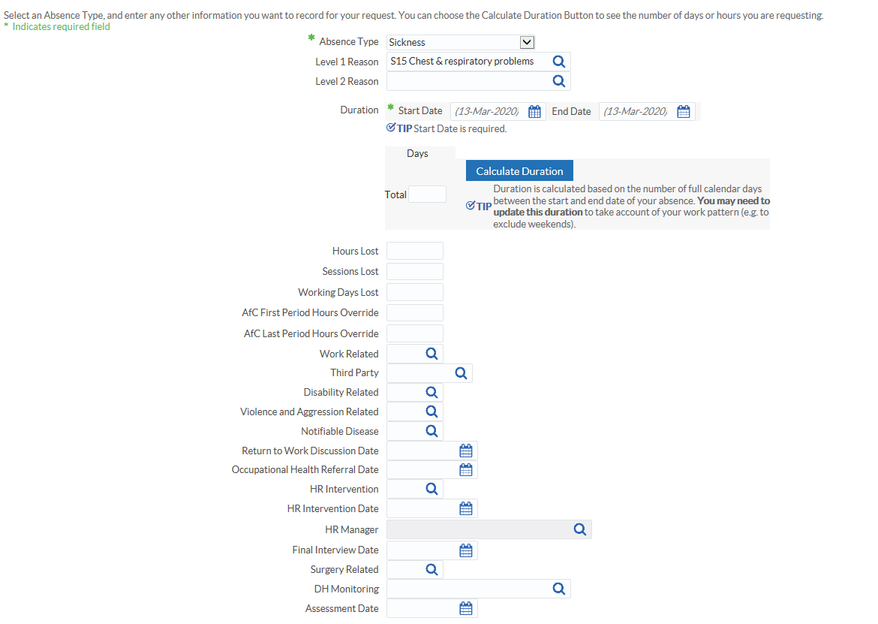

9 - Select “Related Reason” field

10 - Click on the magnifying glass and select option “Coronavirus (COVID-19)”



11 - Top right hand corner – select “Submit”



**How to Report COVID-19 Self-Isolation in ESR Manager / Supervisor Self Service**

Please follow steps 1 through to 7 as detailed above for sickness absence

8 - Complete the box as below

Absence Type – Special Increasing Bal

Absence Reason – Infection Precaution

Duration – enter start and end date of self-isolation (If not known at the point of entry leave the end date blank).



9 - Select “Related Reason” field



10 - Click on the magnifying glass and select the appropriate option using “Quick Select”

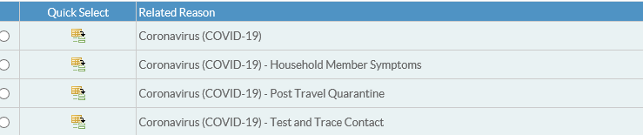

NB: - Coronavirus if employee symptomatic and has to isolate

Coronavirus Household Member Symptoms – If household symptomatic and employee has to isolate because of household member is waiting test results.

Coronavirus Post Travel Quarentine – If the country travelling back from is in on the government red list (no travel corridor) and staff have to quarentine for 14 days following retun to UK. (www.gov.uk/foreign-travel-advice)

Coronavirus Test and Trace Contact – If an employee has been asked to isolate either through the Trusts internal test and trace sytem or the government test and trace system.

11 - Top right hand corner – select “Submit”



**How to Record Sickness & Isolation Absences in HealthRoster**

**Health Roster**

**How to record sickness cases related to Covid-19**

1. Open up e-Roster on the Trust Intranet page.

Click on “System access” in the quick links bar

Select e-Roster

Log in

1. 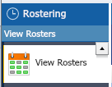Navigate to the ‘View Rosters’ section of the left hand side navigation tab.
2. Direct yourself to your units roster and find the staff member who you are required to input the sickness for via the search tab on the top of the screen



1. 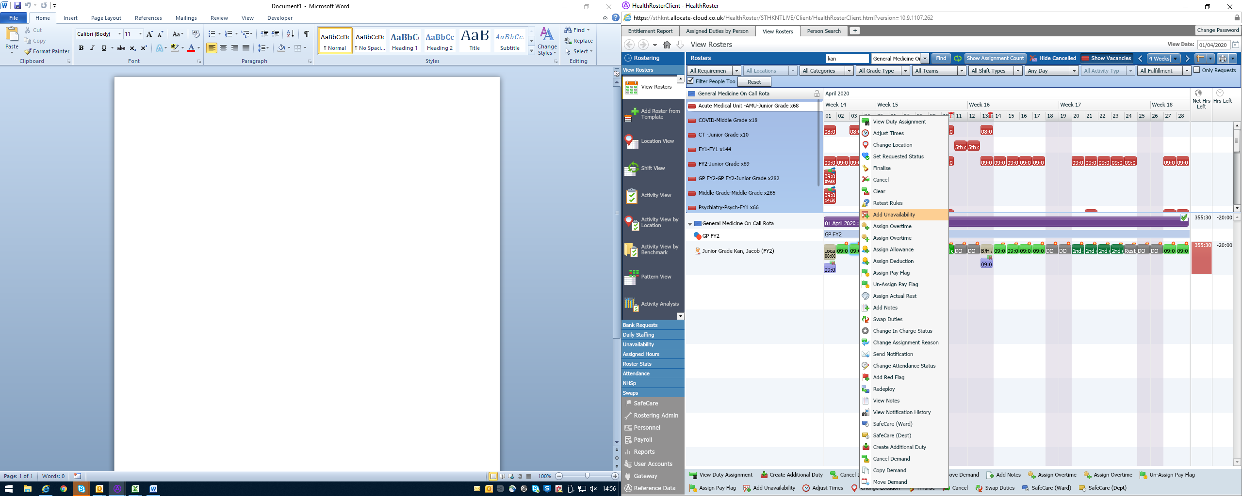Right Click from the day you wish to add the sickness and select ‘ Add Unavalibility’.
2. Follow the below unavailability reasons:

**Group:** ***Sickness***

**Reason :** ***Respirator – COVID-19 – COVID-19***

**Secondary Sickness Reason :** ***COVID-19***

**Start & End Dates:**  ***Amend as appropriate***

**Work Time :** Please ensure the correct amount of usual work hours are entered for the sickness.



Select the start date of the sickness episode on the roster, the option to add unavailability will appear in a task bar at the bottom of the screen.

**How to record isolation for purpose of Covid-19**

Please follow steps 1 through to 4

5. Follow the below unavailability reasons:

**Group:** ***Other Leave***

**Reason :** ***Infec Pre – Infection Precaution, COVID-19***

**Start & End Dates:**  ***Amend as appropriate***

**Work Time :** Please ensure the correct amount of usual work hours are entered for the sickness

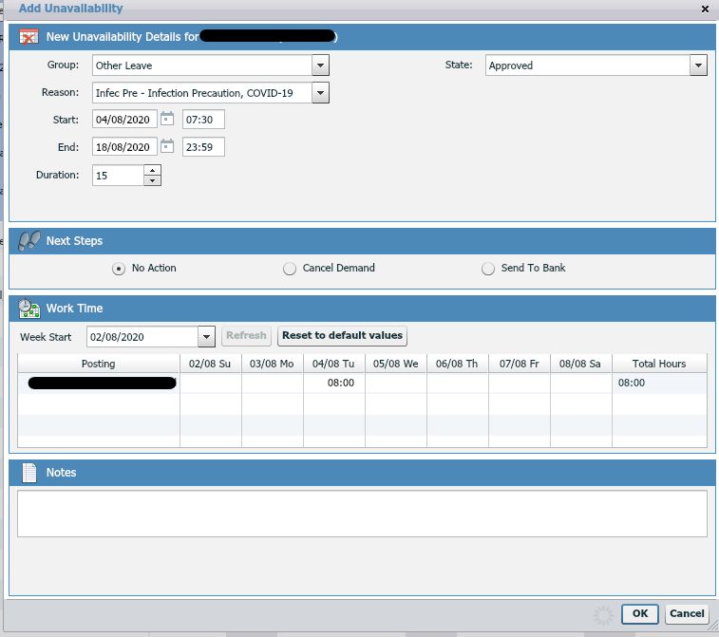

Infec Pre – Infection Precaution COVID-19 – If staff are symtomatic and have to self isolate.



Please select:

Group: Other Leave

Reason: Test and Trace Contact

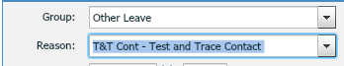

T&T Cont - Test and Trace Contact – If an employee has been asked to isolate either through the Trusts internal test and trace sytem or the government test and trace system.

Reason: Post Travel Quarantine

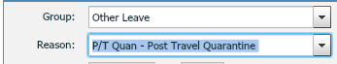

P/T Quan - Post Travel Quarentine – If the country travel from is in on the government red list (no travel corridor) and staff have to quarentine for 14 days following retun to UK. (www.gov.uk/foreign-travel-advice)

Reason: Household Member Symptoms:



HM Sympt - Household Member Symptoms – If household symptomatic and employee has to isolate because of household member is waiting test results