

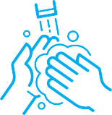

Stay 2m apart

Clean your hands

Wear a face covering/mask

Protect everyone