
Standard Operating Procedure for the Resuscitation of Adults and Children in Cardiac Arrest during time of Pandemic Novel Coronavirus (COVID-19)

Version No: 1

Document Summary:
This SOP lays down the minimum mandatory standards of practice to be applied for the management of patients in cardiac arrest from the Out of Hospital environment, within the Urgent & Emergency Care environment and patients with suspected or proven COVID-19 within the trust.

Document status | Approved
Document type | Standard Operating Procedure (SOP) | Trust wide
Document number | STHK
Approving body | Clinical Effectiveness Council
Date approved | Click here to enter a date.
Date implemented | Click here to enter a date.
Review date | *3 years from approval date Click here to enter a date.
Accountable Director | Medical Director
Policy Author | Head of Resuscitation Services
Target audience | All staff

The intranet version of this document is the only version that is maintained. Any printed copies should therefore be viewed as “uncontrolled”, as they may not contain the latest updates and amendments.

Document Control

Section 1 – Document Information
Title | Standard Operating Procedure for the Resuscitation of Adults and Children in Cardiac Arrest during time of Pandemic Novel Coronavirus (COVID-19))
Directorate |  | Operations
Brief Description of amendments
New Document

Does the document follow the Trust agreed format? |  |  | Yes
Are all mandatory headings complete? |  |  | Yes
Does the document outline clearly the monitoring compliance and performance management? |  |  | Yes
Equality Analysis completed? |  |  | Yes

Section 2 – Consultation Information
Consultation Completed
Consultation start date | 01/05/2020 |  | Consultation end date | 01/06/2020

Section 3 – Version Control
Version | Date Approved | Brief Summary of Changes
 | Click here to enter a date.
 | Click here to enter a date.
 | Click here to enter a date.
 | Click here to enter a date.
 | Click here to enter a date.

Section 4 – Approval – To be completed by Document Control
Document Approved
Assurance provided by Author & Chair
Date approved | Click here to enter a date. |  | Review date | Click here to enter a date.

Section 5 – Withdrawal – To be completed by Document Control
Reason for withdrawal
Assurance provided by Author & Chair
Date Withdrawn: | Click here to enter a date.

Quick Reference Guide

Standard Operating Procedure (SOP) Aim

The aim of this SOP is to support best practice in the event of any person requiring cardiopulmonary resuscitation during the COVID-19 pandemic by a member of clinical staff with direct patient/client contact employed by St Helens and Knowsley Teaching Hospitals NHS Trust (STHK).

SOP Description

The Resuscitation Group is responsible for the compliance with the Cardiopulmonary Resuscitation Policy and the Standard Operating Procedure for the Resuscitation of Adults and Children in Cardiac Arrest during time of Pandemic Novel Coronavirus (COVID-19) within the Trust.

The Trust has an Adult Medical Emergency Team, Trauma Team, Paediatric Emergency Team, Pregnant Woman Emergency Team and Neonatal Team available to attend cardiopulmonary arrests or deteriorating patients at all times on the Whiston site.

Similarly, there is an Emergency Team at St Helens Hospital available to attend cardiac arrests or medical emergencies for adults or paediatrics at all times.

Clear guidelines are available for when and how to call for the Medical Emergency team (available on the hospital intranet).

Operational Policy for the Whiston Medical Emergency Team
National and international guidelines for the management of cardiopulmonary arrest are followed (available on the hospital intranet).

Appropriate equipment will be available throughout the Trust for use on any person requiring resuscitation and for training purposes.

Cardiopulmonary Resuscitation (CPR) episodes will be documented and audited to assess standards of care.

All clinical staff throughout STHK will be provided with regular resuscitation training appropriate to their expected abilities and roles.

At Newton and other community outlying sites where Trust staff work and treat patients the priority is to access paramedic support via the 999 service (see guidance for community in appendix 14).

Contents
Document Control 2
Quick Reference Guide 3
1. Scope 6
2. Introduction 6
3. Statement of Intent 6
4. Definitions 6
5. Duties, Accountabilities and Responsibilities 7
5.1 The Trust Board 7
5.2 Clinical Effectiveness Council 7
5.3 The Resuscitation Group 7
5.3.1 Resuscitation Group – Quality Standards for cardiopulmonary resuscitation practice and training 7
5.4 Chief Executive 8
5.5 Medical Director - Executive Lead for Resuscitation 8
5.6 The Head of Resuscitation Services 8
5.7 Line manager/Clinical Leads 8
5.8 All Staff 8
6. Process 8
6.1 Recognition of cardiac arrest and initial response: 8
6.2 During Cardiac Arrest 9
6.3 Post Cardiac Arrest 10
6.4 For patients being treated on ITU: 10
6.5 Unified Do Not Attempt Cardio-Pulmonary Resuscitation (uDNACPR) 11
7. Training 11
8. Monitoring Compliance 11
8.1 Key Performance Indicators (KPIs) of the SOP 11
8.2 Performance Management of the Policy 12
9. References 12
10. Related Trust Documents 12
11. Equality Analysis Form 13
Appendix 1 – NWAS Clinical Information CV025 Management of Cardiac Arrest 14
Appendix 2 – RCUK Adult ALS for COVID-19 patients in the Hospital Setting 16
Appendix 3 – RCUK Pathway for Paediatric Resuscitation 17
Appendix 4 – RCUK Pathways for the perinatal period 18
Appendix 5 – RCUK FAQs for staff around COVID-19 patients and resuscitation 20
Appendix 6 – RCUK Guidance on Resuscitation of adult COVID-19 in acute hospital settings and Decision Making 21
Appendix 7 – RCUK Statement around PPE and PHE Guidance 22
Appendix 8 – PHE Guidance on ‘donning’ and ‘doffing’ PPE 23
Appendix 9 – HME Filter and Bag Valve Mask Device 25
Appendix 10 – Fitting a HME Filter to a Bag Valve Mask Device 26
Appendix 11 – Cardiac arrest in the Prone Position 27
Appendix 12 – PPE & IV Access ‘Grab bags’ Contents Lists 30
Appendix 13 – Delivering 3 stacked shocks using an AED 31
Appendix 14 – RCUK Statement on COVID-19 in relation to CPR and resuscitation in first aid and community settings 32

Scope

The Standard Operating Procedure describes the modified processes and treatments, from the standard Resuscitation Council UK pathways and guidance, pertinent to the resuscitation of all adults and children during the COVID-19 pandemic.

These pathways have been introduced during the COVID-19 pandemic and are for use for all patients who arrive into the Trust or are currently within the Trust.

Introduction

- The Resuscitation Council UK have issued guidelines for cardiopulmonary resuscitation practice during the COVID-19 pandemic which must be followed. This includes the correct mandated use of PPE and the delivery of 3 stacked shocks if appropriate.

- Clinical Governance requires that national standards be met in order to provide a consistently high quality service that minimises potential risk to patients.

Statement of Intent

- To provide Trust Staff with direction and guidance for the planning and implementation of a high-quality and robust resuscitation service to the organisation during the COVID-19 pandemic. The policy for resuscitation incorporates the current published guidelines for resuscitation (Resuscitation Council (UK) 2015 (Appendix 2).

- To ensure patient and person(s) important to the person receive safe, effective and compassionate care.

- To ensure Trust Staff are protected from potential aerosol spray during cardiopulmonary resuscitation.

- To establish guidelines that act as a point of reference for medical, nursing staff and other members of the multi-disciplinary team.

- To ensure a consistent level of good practice across the Trust.

Definitions/abbreviations

Definition | Meaning
ABG | Arterial Blood Gases
AGP | Aerosol Generating Procedure
ALS | Advanced Life Support
BVM | Bag Valve Mask
CFS | Clinical Frailty Score
CPR | Cardiopulmonary Resuscitation
DNACPR | Do No Attempt CPR
ED | Emergency Department
HCW | Healthcare Worker
HME | Heat Moisture Exchange
IPC | Infection Prevention Control
NWAS | North West Ambulance Service
OOH | Out of Hospital
PPE | Personal Protective Equipment
RCUK | Resuscitation Council of the United Kingdom and Ireland
WHO | World Health Organisation

Duties, Accountabilities and Responsibilities

Healthcare organisations have an obligation to provide an effective resuscitation service to their patients and appropriate training to their staff. A suitable infrastructure is required to establish and continue support for these activities.

The Trust Board

The Trust Board has responsibility for the appropriate provision of information, education, training and audit relating to resuscitation and ‘Do Not Attempt Cardio Pulmonary Resuscitation’ (DNACPR) orders. The Trust Board has overall responsibility for ensuring that Resuscitation Services has sufficient resources to facilitate the implementation of all elements of this SOP.

Clinical Effectiveness Council

The Clinical Effectiveness Council will approve the SOP and ensure that assurance can be given to the Trust Board that the SOP is being implemented and monitored for compliance.

The Resuscitation Group

The Resuscitation Group is the expert advisory group on all matters relating to resuscitation and associated topics e.g. COVID – 19. Compliance with the Resuscitation policy and the associated key performance indicators (KPIs) will be monitored and evaluated by this group, with the appropriate assurance of risk factors being addressed and fed back to the Clinical Effectiveness Council for their advice and/or approval. The Resuscitation Group will ensure that this SOP and procedures comply with current national Resuscitation Guidelines, the Care Quality Commission and NHSLA Standard 4 Criterion 8 The deteriorating patient.

Resuscitation Group – Quality Standards for cardiopulmonary resuscitation practice and training

The Resuscitation Group must be part of the organisation’s governance structure (e.g. Clinical Effectiveness Council)

The Resuscitation Group must include representatives from stakeholder groups (e.g. doctors, nurses, resuscitation officers, pharmacists, management, patient/lay representative), and appropriate specialties (e.g. ambulance service, anaesthesia, cardiology, dentistry, emergency medicine, general practice, intensive care medicine, mental health, neonatology, obstetrics, paediatrics). The exact composition of the Group will depend on local needs and arrangements.
The chair of the Resuscitation Group must be a senior clinician with an active and credible involvement in resuscitation. This individual would be expected to have the authority to drive and implement change.

The Resuscitation Group must have administrative support.

The Resuscitation Group is responsible for implementing operational policies governing cardiopulmonary resuscitation practice and training.
Depending on local arrangements, it is recommended that the Resuscitation Group provides advice to other local healthcare organisations who do not have the necessary expertise in resuscitation issues. In some healthcare communities this is achieved very effectively by having a Resuscitation Group that spans all the relevant organisations.

The Resuscitation Group must determine the level of resuscitation training required by staff members.

At least twice-yearly meetings of the Resuscitation Group are recommended. STHK’s Resuscitation Group usually meets quarterly.

Responsibilities of the Resuscitation Group are included in the Quality Standards for cardiopulmonary resuscitation practice and training.

Chief Executive

The Chief Executive has a duty to ensure adequate resources are available to enable effective implementation of this policy. Also to ensure this policy is implemented according to the nationally agreed Quality Standards.

Medical Director - Executive Lead for Resuscitation

The Medical Director has delegated executive responsibility for assuring the Board of Directors of the effective implementation of this policy through the monitoring processes of the Clinical Effectiveness Council.

The Head of Resuscitation Services

The Head of Resuscitation Services is responsible for ensuring all policy relating to resuscitation practice is based on best evidence and is implemented and monitored effectively and efficiently.

Line manager/Clinical Leads

Line Managers/Clinical Leads will take responsibility for assuring staff compliance with all elements of this policy within their remit.

All Staff

Individual STHK staff will take responsibility for familiarising themselves with this policy and ensuring their compliance. Each Assistant Director of Operations is responsible for ensuring that all clinical staff within their Care Group attend appropriate resuscitation training.

Process

Recognition of cardiac arrest and initial response:

- Check response – shake and shout (do not perform head tilt or chin lift).

- Check for signs of life or breathing – look only (do not listen or feel for breaths).

- Call for help – to colleague outside room to call 2222 – alert Switchboard to the risk of COVID-19 and get the emergency trolley.

- Switchboard will put out an emergency call to the arrest team as normal – the bleep will read ‘COVID’ to alert cardiac arrest team.

- **Do not perform mouth to mouth or pocket mask ventilation**.

- If the patient is already receiving supplemental oxygen therapy using a face mask, leave the mask on the patient’s face as this may limit aerosol spread. If not in situ, but one is readily available, put a simple oxygen mask on the patient’s face.

During Cardiac Arrest

- No more than 5 team members to enter a room or bay whilst a cardiac arrest is in progress.

- Cardiac Arrest Trolley MUST stay outside the room.

- Defibrillator and pads to be passed into the room first, person wearing surgical mask, plastic apron, gloves and eye protection to deliver 3 stacked shocks, if shockable rhythm, then leave the room – no ventilations or compressions until full PPE has been donned. For delivering 3 stacked shocks using an AED (orange NK Defib), please see appendix 13.

- One person to stay with the trolley outside the room as “Gatekeeper” wearing a surgical mask, plastic apron, gloves and eye protection. They must ensure only 5 team members maximum enter the room.

- The Gatekeeper must ensure staff don long sleeved surgical gown, gloves, FFP3 mask and visor or goggles before entering the room and starting resuscitation. Visors should be used when available, if none available and the PPE mask has a valve, then a surgical mask must be put on over the FFP3 valve mask and googles worn. Full PPE x 5 stored in bottom of the arrest trolley and in ward clean utility room (See appendix 12 for contents list). The PPE Grab bags should be locally replenished after use, however Cardio-respiratory has an ‘emergency’ supply if required.

- Once full PPE has been donned, chest compressions and face-mask ventilation, using a BVM device with a HME Filter connected between the bag and mask, must be commenced (see appendix 9 & 10). For many HCWs this will mean two-person bag-mask technique.

- Advanced airway management, intubation and use of iGels to be performed by anaesthetic staff only.

- The Gatekeeper is responsible for passing items from the trolley into the room as required by finger-tip. There are emergency IV access grab bags available on top of the resuscitation trolley to be passed into the room to reduce the need to open the door multiple times (see appendix 12 for contents list). These need to be locally replenished after use.

- Disposable equipment must not leave the room until bagged for disposal.

- Blood samples are to be placed in a blue bag held by an external member (not the gatekeeper) they will complete a requisition form if required. In the case of ABGs this person (someone who can do ABG testing) should take the ABG sample (using the ‘Safe PICO Aspirator Sampler’ syringe) to the nearest ABG machine available to carry out the testing wearing gloves.

- Identify and treat any reversible causes (e.g. severe hypoxaemia) before considering stopping CPR. For full resuscitation guidance, please refer to appendix 2 (or appendix 3 for Paediatrics).

- Discussion should be maintained throughout the resuscitation event and early planning of the post resuscitation phase undertaken. Contact senior help and gain advice from critical care partners as part of the planning.

Post Cardiac Arrest

- Non-disposable equipment – defibrillator, leads etc must be cleaned as per IPC instructions immediately to ensure equipment is available as soon as possible. Any work surfaces used for airway/resuscitation equipment will also need to be cleaned according to local guidelines. Specifically, ensure equipment used in airway interventions (e.g. laryngoscopes, face masks) is not left lying on the patient’s pillow, but is instead placed in a tray. Do not leave the Yankauer sucker placed under the patient’s pillow; instead, put the contaminated end of the Yankauer inside a disposable glove.

- Remove PPE safely to avoid self-contamination and dispose of clinical waste bags as per local guidelines. Hand hygiene has an important role in decreasing transmission. Thoroughly wash hands with soap and water; alternatively, alcohol hand rub is also effective.

- Post resuscitation debrief is important and should be planned.

Please see flow charts/algorithms in the attached appendices for clinical and departmental processes with regards to patients that are in cardiac arrest arriving from the Out of Hospital (OOH) environment and for those patients who have a cardiac arrest with suspected or proven COVID-19 across the Trust.

For patients being treated on ITU:

Depending on the cause and time point during CPR, CPR can start with the patient in the prone position (see appendix 11). Specifically:

- Chest compressions can be started by compressing the spine in between the scapulae (shoulder blades). The same compression rate (100-120/min) and depth of compression (5-6 cm) as conventional chest compression should be used. Aim for a diastolic pressure of 25 mmHg on the arterial line.

- If the cardiac arrest rhythm is shockable, attempt defibrillation by placing the defibrillator pads in a bi-axillary (both armpits in the mid-axillary line) or antero-posterior (front and back) position.
- If there is a problem with the airway (e.g. displacement of tracheal tube), it will be necessary to rapidly turn the patient supine – this requires practice and should be planned for in units managing prone patients with COVID-19.

- If initial attempts at resuscitation are unsuccessful, or chest compressions are ineffective turn the patient supine to facilitate resuscitation.

- It may be possible to continue mechanical ventilation during continuous chest compressions by making adjustments to the ventilator settings and not disconnecting the ventilator. Set the ventilator at 10 breaths per minute. If there is a need to break the circuit, follow guidance for disconnection to minimise aerosol generation. Full guidance available at:
https://static1.squarespace.com/static/5e6613a1dc75b87df82b78e1/t/5e72187c06c2956228316545/1584535679039/FICM-ICS-Prone-Position-Adult-Full.pdf

Unified Do Not Attempt Cardio-Pulmonary Resuscitation (uDNACPR)

- When considering decisions and completing the uDNACPR Lilac form, patients can be acutely unwell and recovery could be uncertain.

- This decision must be reviewed when clinical circumstances change and prior to the patient leaving the hospital (specifically when COVID-19 was a criterion for the decision).

- Most uDNACPR decisions will remain in place appropriately, but some will warrant reversal. This could be the case for some patients with COVID19.

- This uDNACPR review MUST be completed by the Senior Medical/Clinical Team caring for the patent and discussed with the patient and communicated to outside agencies upon discharge.

Training

During the COVID – 19 pandemic level 2 Basic Life Support training is still mandated and must be achieved using the Resus Quality Improvement (RQI) skills station.

Monitoring Compliance

Key Performance Indicators (KPIs) of the SOP

No | Key Performance Indicators (KPIs) Expected Outcomes
1 | Review of all 2222 cardiac arrests
2 | Good practice observed at cardiac arrests
3 | Monitor Cardiac Arrest DATIX incidents

Performance Management of the Policy

Minimum Requirement to be Monitored | Lead(s) | Tool | Frequency | Reporting Arrangements | Lead(s) for acting on Recommendations
SOP to be followed during pandemic | Resuscitation Officers | DATIX and attendance at Emergency Calls | Ongoing | Silver Command | Head of Resuscitation Services

References

No | Reference
1 | Resuscitation Council:  https://www.resus.org.uk/media/statements/resuscitation-council-uk-statements-on-covid-19-coronavirus-cpr-and-resuscitation/covid-healthcare-resources/
2 | Intensive Care Management:  https://icmanaesthesiacovid-19.org/critical-care-preparation-and-management-in-the-covid-19-pandemic
3 | Coronavirus Infection Prevention and Control: https://www.gov.uk/government/publications/wuhan-novel-coronavirus-infection-prevention-and-control

Related Trust Documents

No | Related Document
1 | COVID 19 Standard Operating Procedure
2 | Resuscitation Policy

Equality Analysis Form
The screening assessment must be carried out on all policies, procedures, organisational changes, service changes, cost improvement programmes and transformation projects at the earliest stage in the planning process to ascertain whether a full equality analysis is required. This assessment must be attached to all procedural documents prior to their submission to the appropriate approving body. A separate copy of the assessment must be forwarded to the Patient Inclusion and Experience Lead for monitoring purposes. Cheryl.farmer@sthk.nhs.uk. If this screening assessment indicates that discrimination could potentially be introduced then seek advice from the Patient Inclusion and Experience Lead. A full equality analysis must be considered on any cost improvement schemes, organisational changes or service changes which could have an impact on patients or staff.
Equality Analysis
Title of Document/proposal /service/cost improvement plan etc: |  |  | Click here to enter text.
Date of Assessment |  | 05/05/2020 |  |  | Name of Person completing assessment /job title: |  |  | Paul Cravan
Lead Executive Director |  | Medical Director |  |  |  |  |  | Head of Resuscitation Services
Does the proposal, service or document affect one group more or less favourably than other group(s) on the basis of their: |  |  |  | Yes / No |  |  | Justification/evidence and data source
1 | Age |  |  | No |  |  | N/A
2 | Disability (including learning disability, physical, sensory or mental impairment) |  |  | No |  |  | N/A
3 | Gender reassignment |  |  | No |  |  | N/A
4 | Marriage or civil partnership |  |  | No |  |  | N/A
5 | Pregnancy or maternity |  |  | No |  |  | N/A
6 | Race |  |  | No |  |  | N/A
7 | Religion or belief |  |  | No |  |  | N/A
8 | Sex |  |  | No |  |  | N/A
9 | Sexual Orientation |  |  | No |  |  | N/A
Human Rights – are there any issues which might affect a person’s human rights? |  |  |  | Yes / No |  |  | Justification/evidence and data source
1 | Right to life |  |  | No |  |  | N/A
2 | Right to freedom from degrading or humiliating treatment |  |  | No |  |  | N/A
3 | Right to privacy or family life |  |  | No |  |  | N/A
4 | Any other of the human rights? |  |  | No |  |  | N/A
Lead of Service Review & Approval
Service Manager completing review & approval  Job Title: |  |  |  |  |  | Click here to enter text.
 |  |  |  |  |  | Click here to enter text.

Appendix 1 – NWAS Clinical Information CV025 Management of Cardiac Arrest

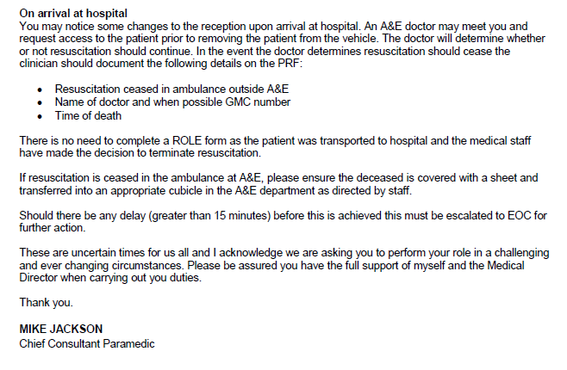

Appendix 2 – RCUK Adult ALS for COVID-19 patients in the Hospital Setting
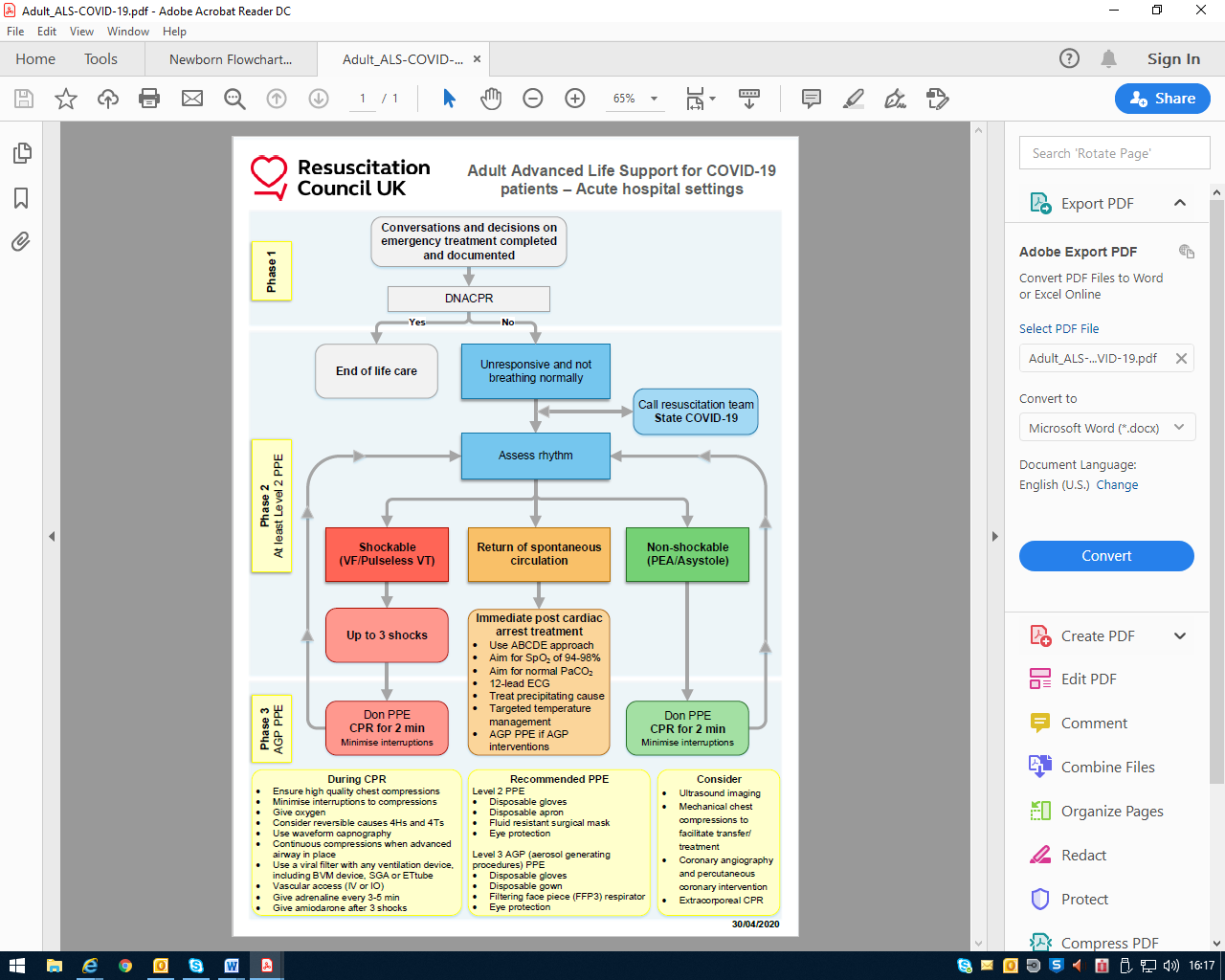

Appendix 3 – RCUK Pathway for Paediatric Resuscitation

Appendix 4 – RCUK Pathways for the perinatal period
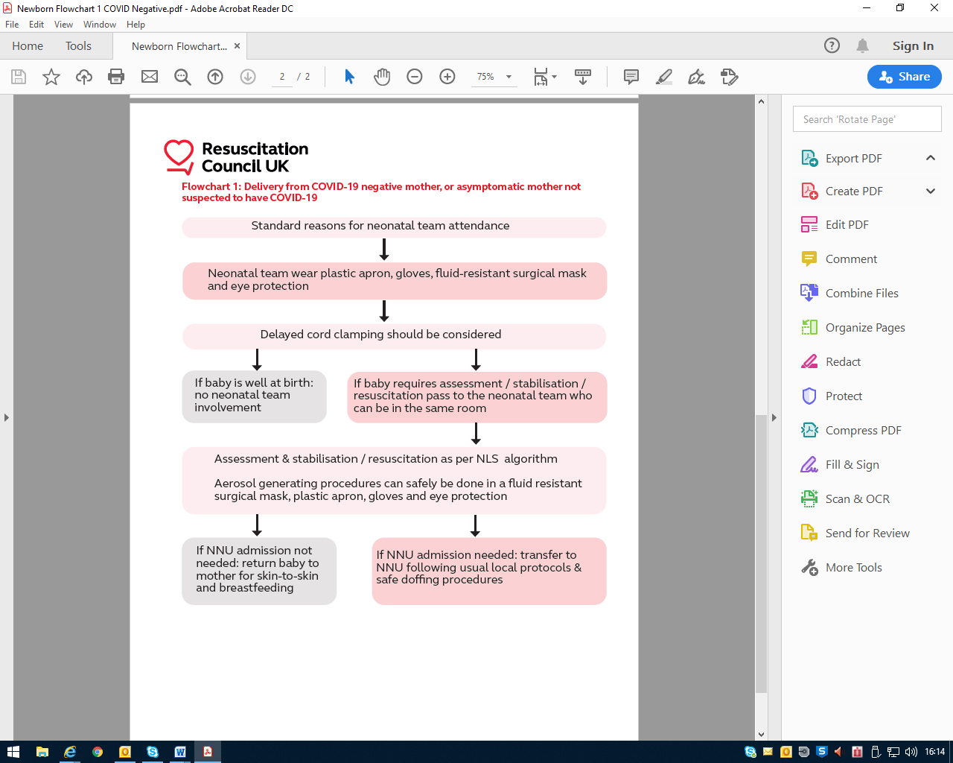
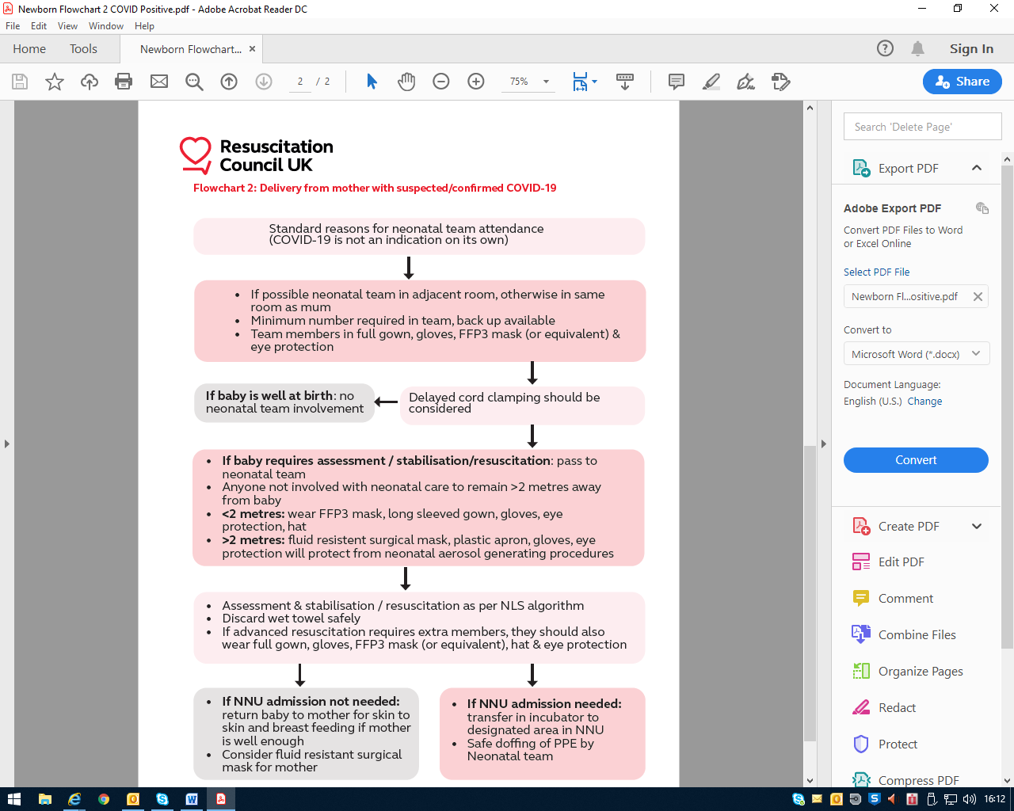

Appendix 5 – RCUK FAQs for staff around COVID-19 patients and resuscitation
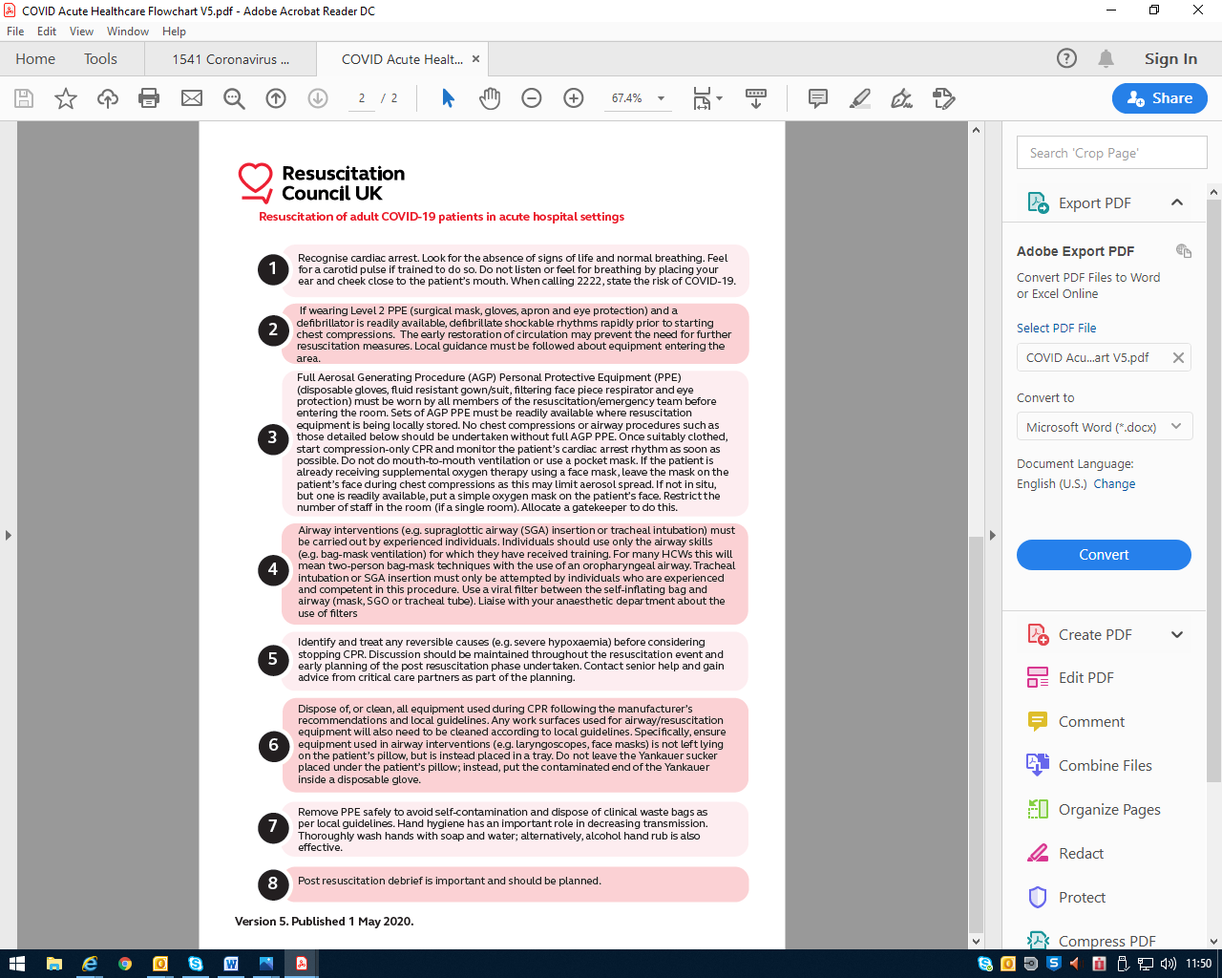

Appendix 6 – RCUK Guidance on Resuscitation of adult COVID-19 in acute hospital settings and Decision Making
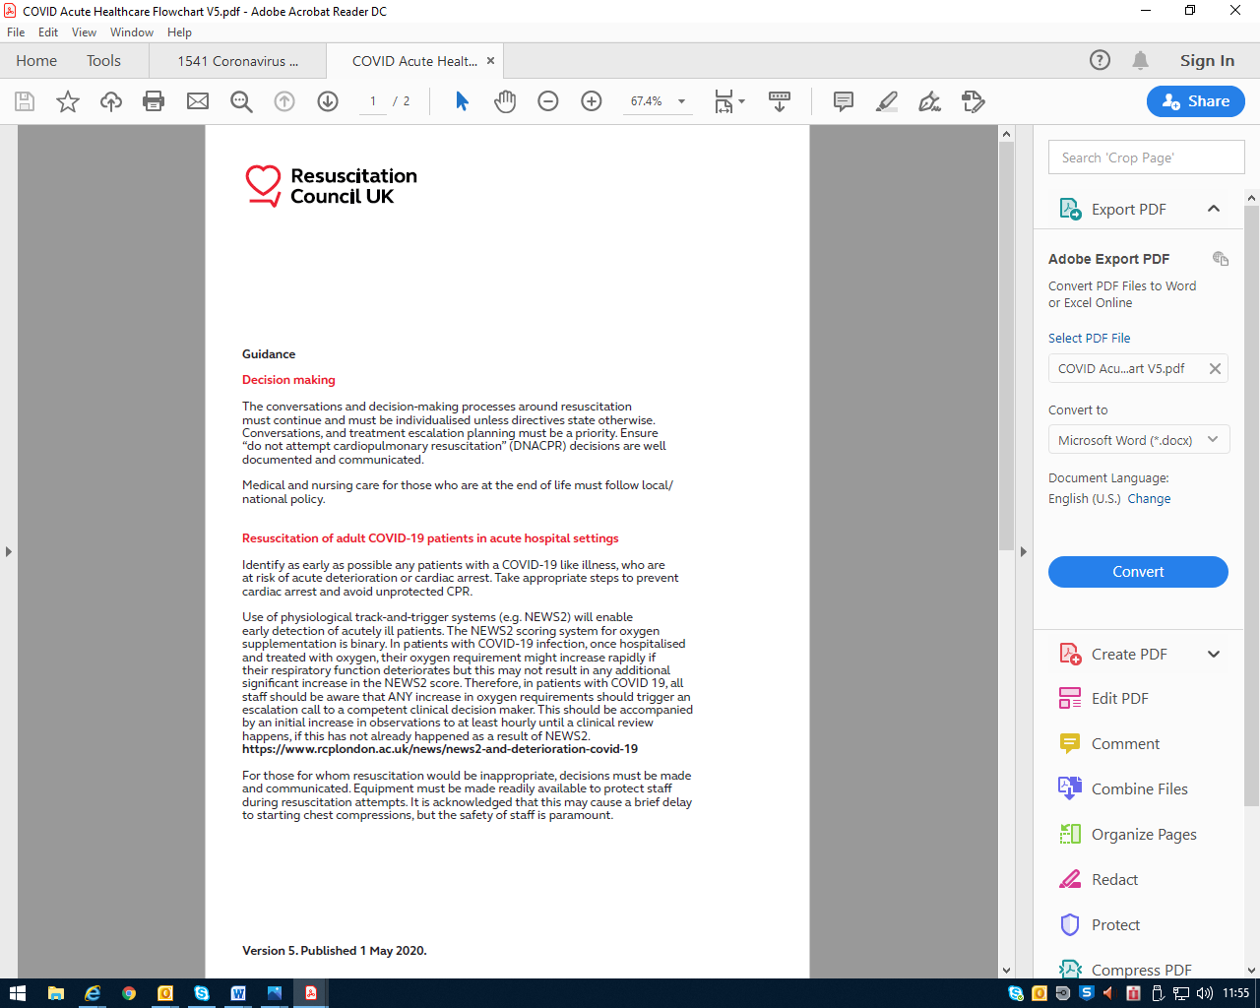

Appendix 7 – RCUK Statement around PPE and PHE Guidance

Appendix 8 – PHE Guidance on ‘donning’ and ‘doffing’ PPE
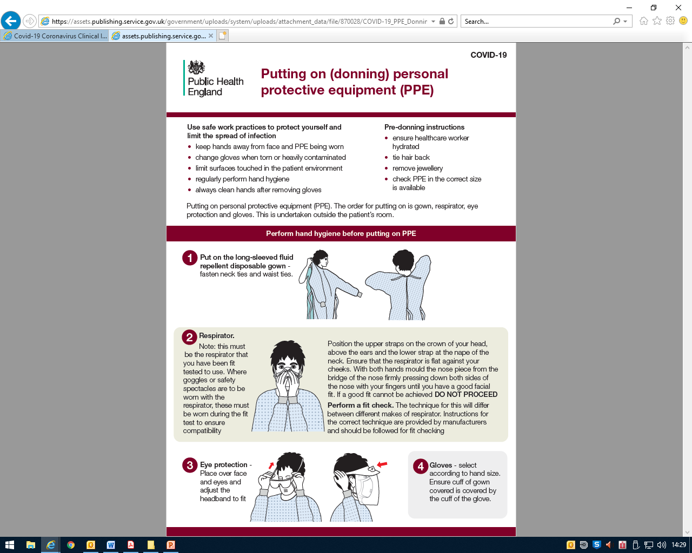

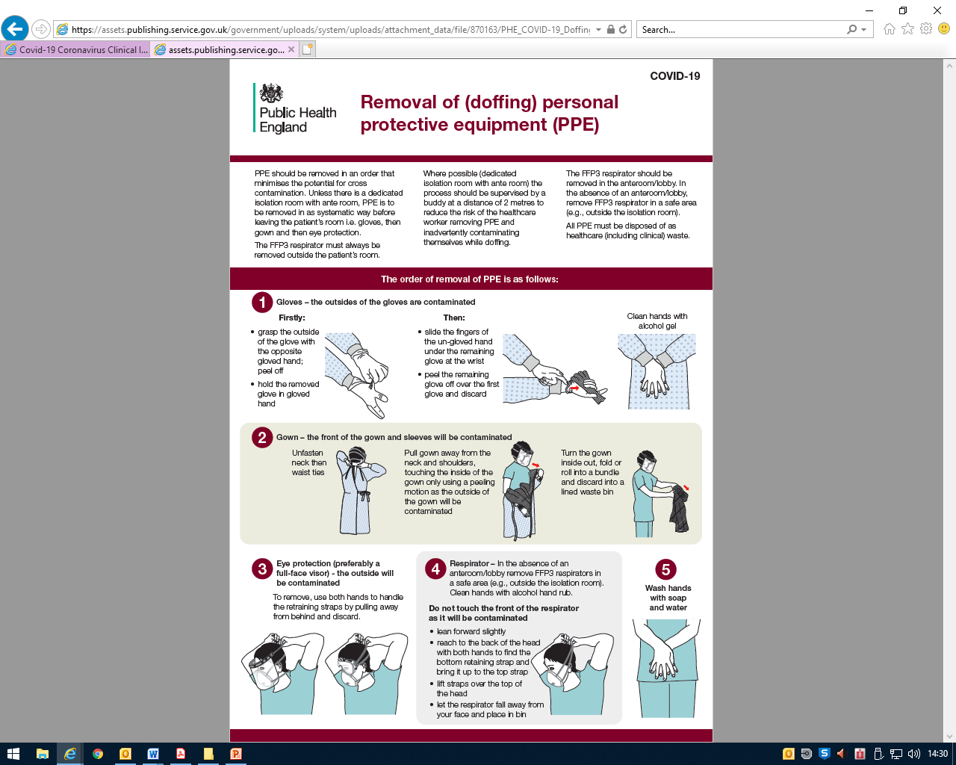

Appendix 9 – HME Filter and Bag Valve Mask Device
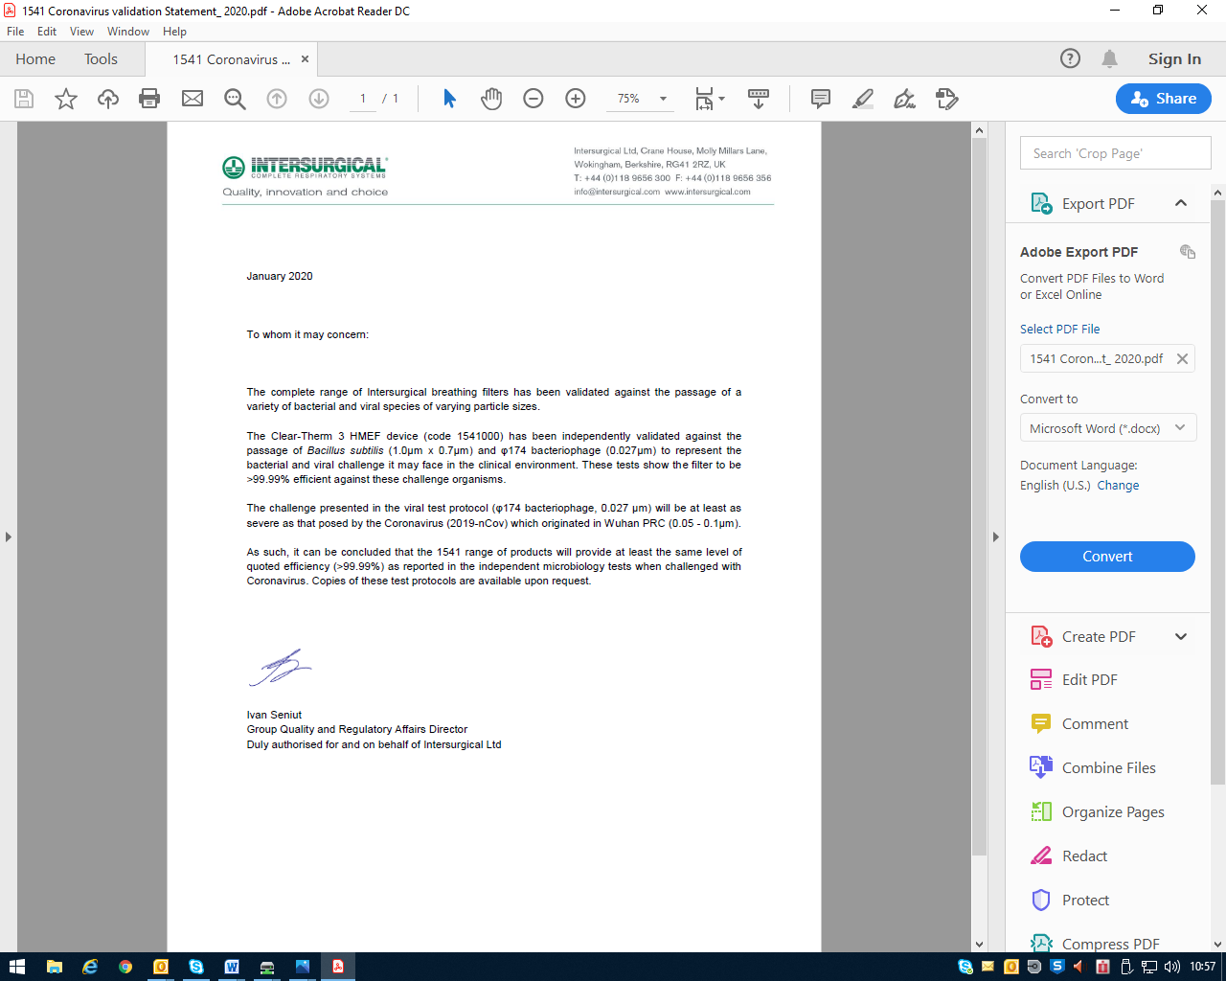

Appendix 10 – Fitting a HME Filter to a Bag Valve Mask Device

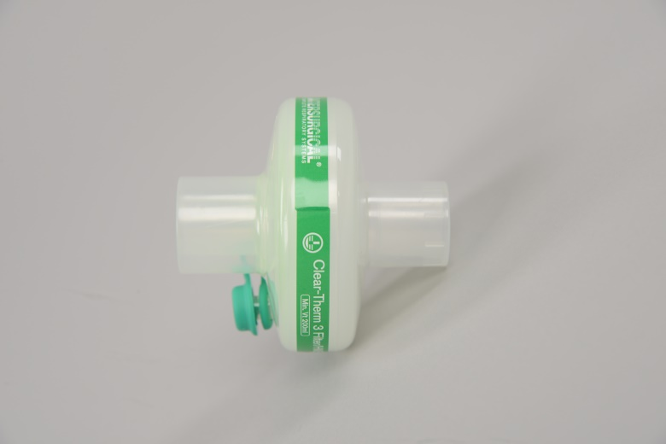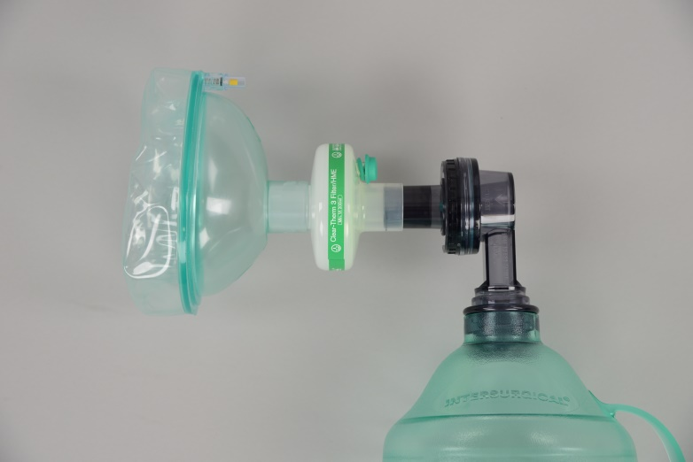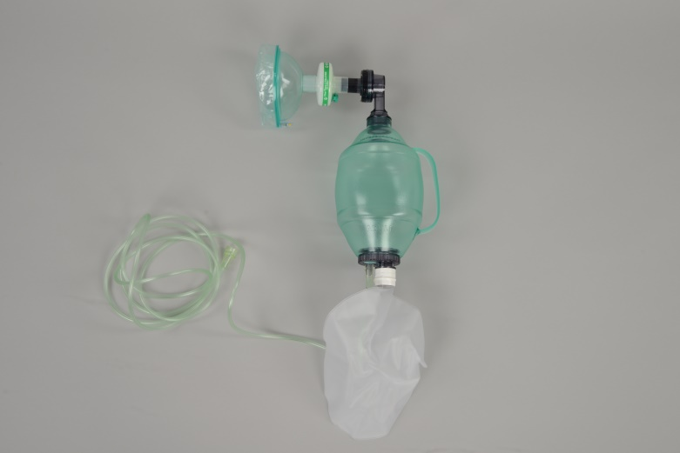
Single-use HME Filters are available at the bottom of the Resuscitation Trolley. Please ensure a filter is fitted BEFORE ventilating SUSPECTED OR CONFIRMED COVID-19 Patients – only after full PPE is Donned
Paediatric HME Filters are available on the appropriate Paediatric Resuscitation Trolley’s
Please replenish after use from Cardio-respiratory

Appendix 11 – Cardiac arrest in the Prone Position
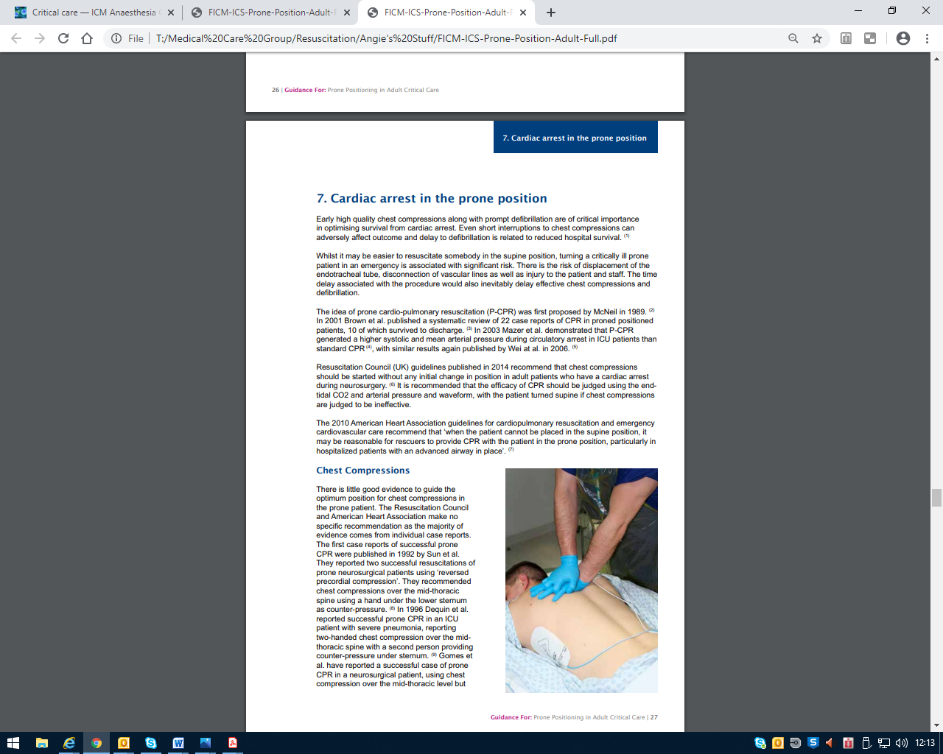

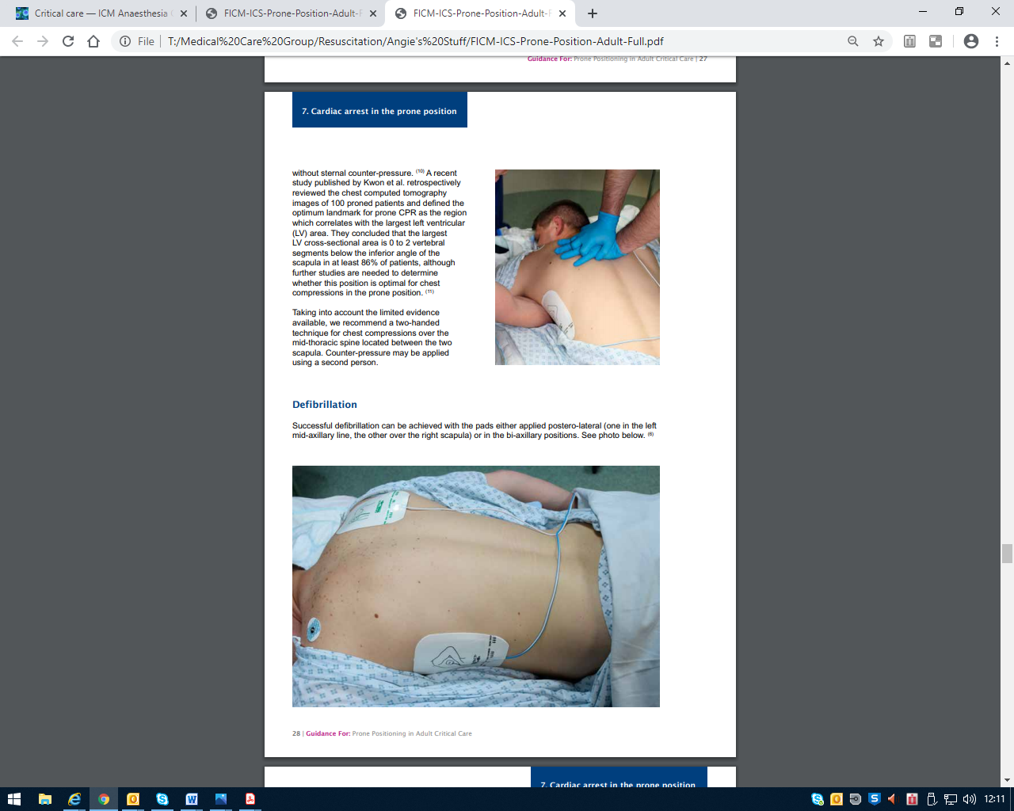

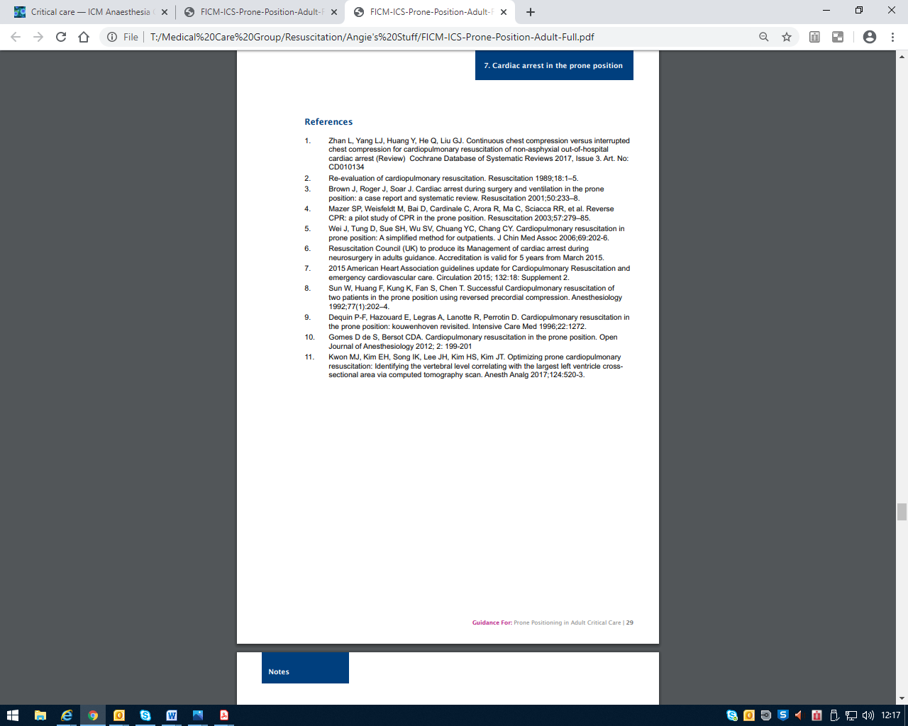

Appendix 12 – PPE & IV Access ‘Grab bags’ Contents Lists
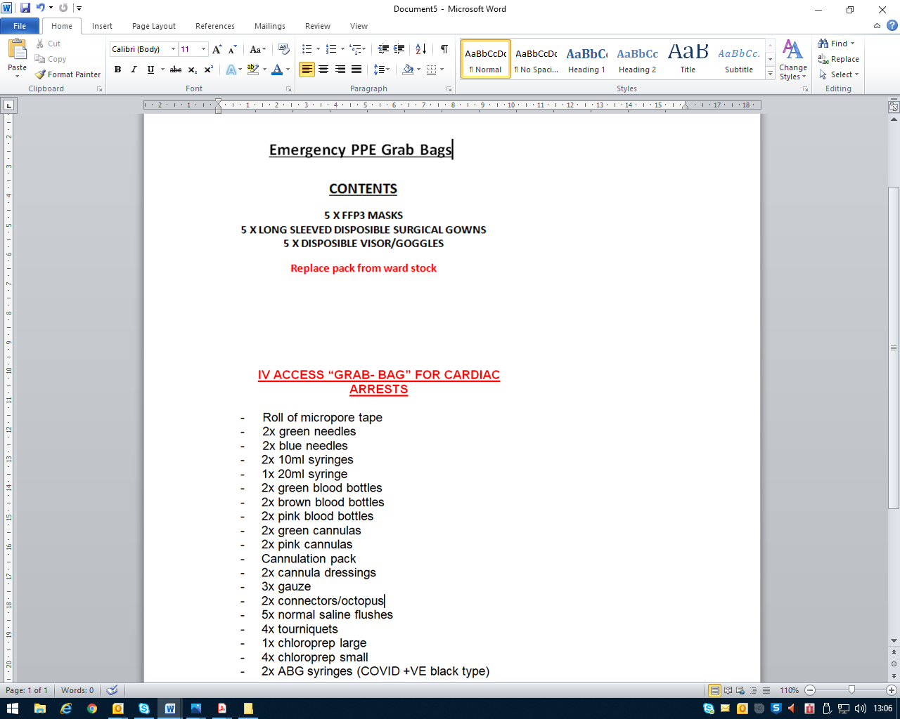

Appendix 13 – Delivering 3 stacked shocks using an AED
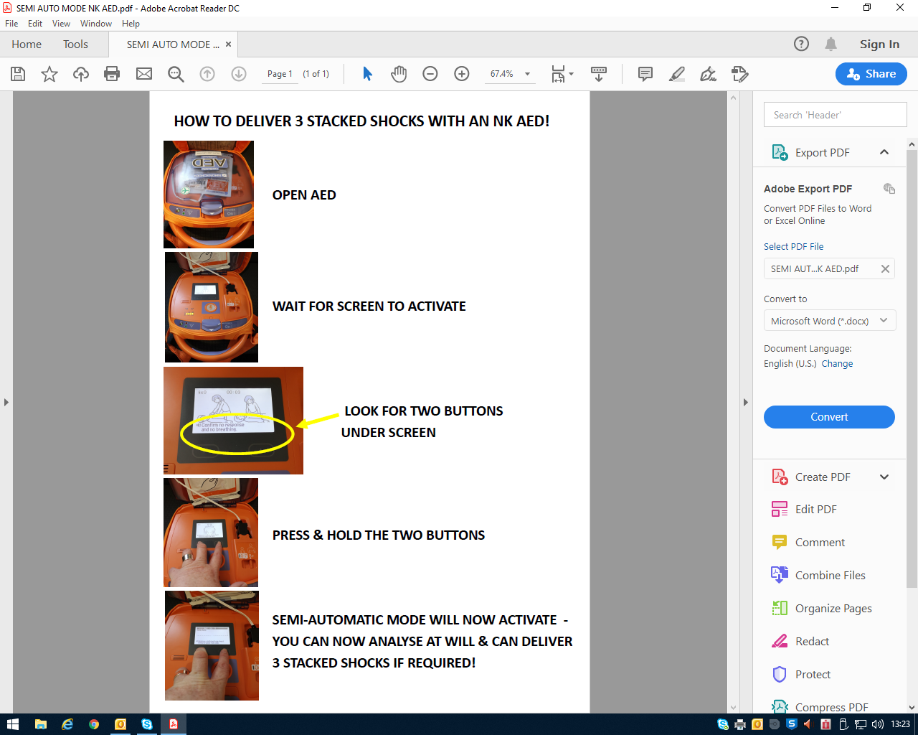

Appendix 14 – RCUK Statement on COVID-19 in relation to CPR and resuscitation in first aid and community settings

