**Appropriate use of PPE for HOSPITAL based staff (including Medirest and Vinci): what is required, where and when**

|  |  |  |  |  |  |  |
| --- | --- | --- | --- | --- | --- | --- |
| **Setting** | **Disposable gloves** | **Disposable plastic apron** | **Disposable fluid resistant gown (or if gown unavailable, disposable coveralls)** | **Fluid-resistant**  **(Type IIR)**  **surgical mask** | **FFP3 mask** | **Eye protection (goggles/visor)** |
| 1. Working in any high risk area:  * ICU/HDU * ED resus * Wards with non-invasive ventilation (NIV) | **√**  **Single use** | **√ Single use** | **√**  **Sessional use** | **X** | **√**  **Sessional use** | **√**  **Sessional use** |
| 1. Carrying out AGP on a suspected or confirmed Covid-19 positive patient in any clinical areas other than those listed in A   OR  Operating theatre (with AGP) | **√**  **Single use** | **X** | **√**  **Single use** | **X** | **√**  **Single use** | **√**  **Single use [Visor preferable to goggles]** |
| 1. Working any clinical area other than those listed in A, (e.g. ED excluding resus, inpatient ward, outpatient clinic, radiology) and providing direct patient care (within 2m of patient) | **√**  **Single use** | **√**  **Single use** | **X** | **√**  **Sessional use** | **X** | **√**  **Sessional use** |
| 1. Working any clinical area other than those listed in A, (e.g. inpatient ward, outpatient clinic, radiology) and not providing direct patient care (not within 2m of patient) | **X** | **X** | **X** | **√**  **Sessional use** | **X** | **√**  **If risk of splashing to face** |
| 1. Staff transferring patients | **√**  **Single use** | **√**  **Single use** | **X** | **√**  **Sessional use** | **X** | **√**  **If risk of splashing to face** |
| 1. Non-patient transport duties to clinical areas e.g. deliveries or collection of goods/equipment | **X** | **X** | **X** | **√**  **Sessional use** | **X** | **X** |
| 1. Operating theatre (with no AGP) | **√**  **Single use** | **X** | **√**  **Single use** | **√**  **Single use** | **X** | **√**  **Sessional use** |
| **Setting** | **Disposable gloves** | **Disposable plastic apron** | **Disposable fluid resistant gown (or if gown unavailable, disposable coveralls)** | **Fluid-resistant**  **(Type IIR)**  **surgical mask** | **FFP3 mask** | **Eye protection (goggles/visor)** |
| 1. Delivery Suite – staff attending 2nd/3rd stage of labour | **√**  **Single use** | **√**  **Single use** | **√**  **Single use** | **√**  **Single use** | **X** | **√**  **Sessional use** |
| 1. When caring for inpatients who are extremely vulnerable or in isolation for non-Covid reasons (e.g. MRSA/VRE/CPE positive) | **√**  **Single use** | **√**  **Single use** | **X** | **√**  **Single use** | **X** | **X** |
| 1. Working in non-patient facing areas (e.g. pharmacy, labs) and unable to maintain 2m social distance | **X** | **X** | **X** | **√**  **Sessional use** | **X** | **X** |
| 1. Working in non-patient facing areas where 2m social distancing can be maintained | **X** | **X** | **X** | **X** | **X** | **X** |

**Appropriate use of PPE for COMMUNITY staff: what is required, where and when**

|  |  |  |  |  |  |  |
| --- | --- | --- | --- | --- | --- | --- |
| **Setting** | **Disposable gloves** | **Disposable plastic apron** | **Disposable fluid resistant gown (or if gown unavailable, disposable coveralls)** | **Fluid-resistant**  **(Type IIR)**  **surgical mask** | **FFP3 mask** | **Eye protection  (goggles/visor)** |
| 1. Providing care in a patient’s home | ****  **Single use** | ****  **Single use** | **X** | ****  **Single use** | **X** | ** If risk of splashing to face** |
| 1. Home births | **√**  **Single use** | **√**  **Single use** | **√**  **Single use** | **√**  **Single use** | **X** | **√**  **Single use** |

**Correct use of FFP3 masks:**

Ensure you have been face fit tested for the mask you are using. Fit testing is available via key trainers in each clinical area.

If a valved, non-shrouded FFP3 respirator is used then it should be accompanied by full face protection for use in AGPs or higher risk acute care areas. For 3M 1873V and 8833 masks (shown below) or any other type of FFP3 mask **with a valve visible from the outside**, additional protection must be used to reduce the risk of droplet splashing. If you are wearing such a mask, wear a full face visor over the mask. If visors are not available, wear a water repellent surgical mask over the FFP3 mask plus goggles.

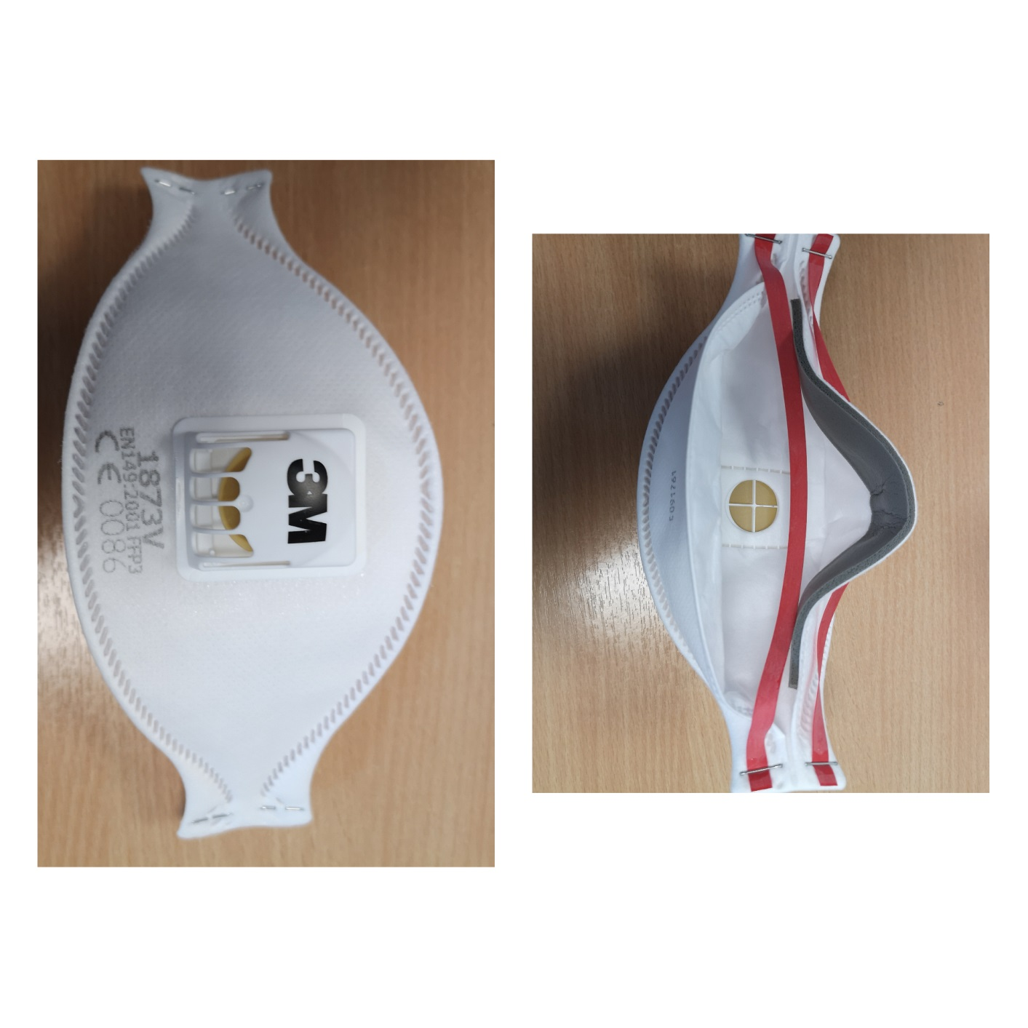

3M 1873V

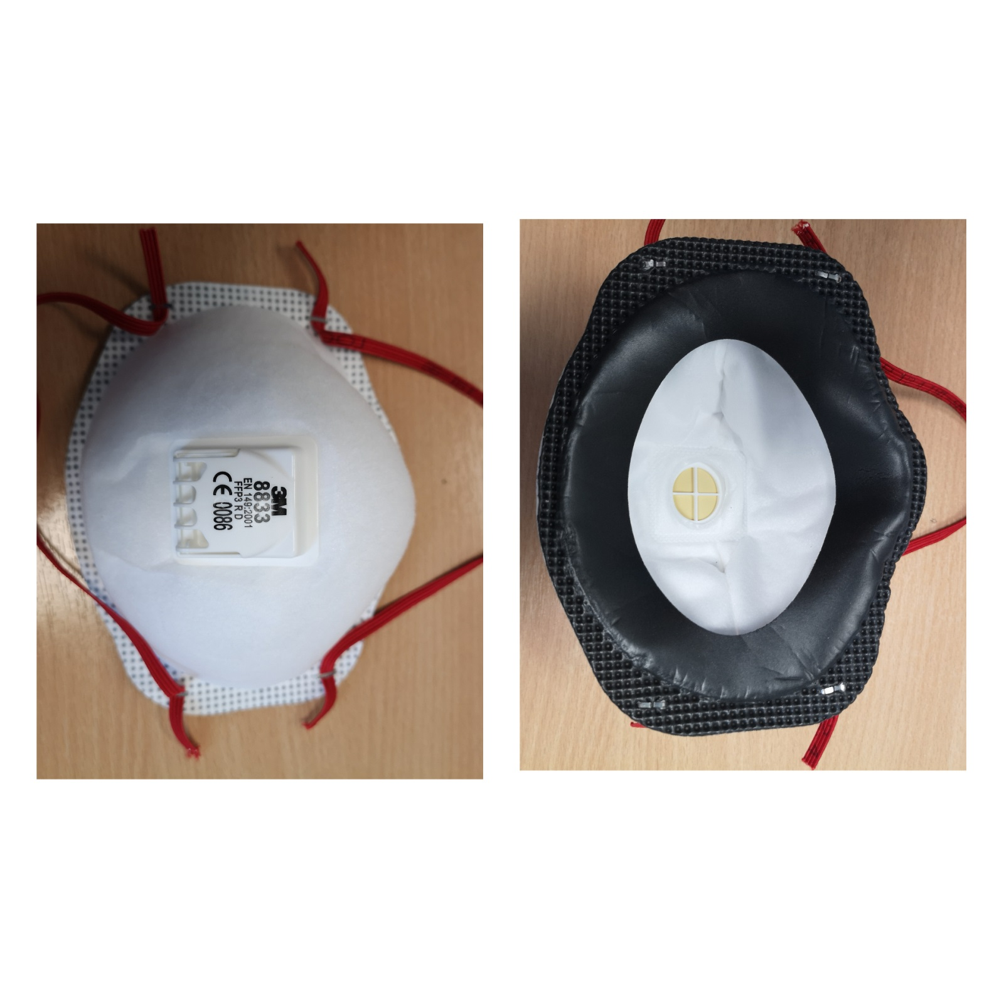

3M 8833

**Single/Reusable/Sessional use PPE explained:**

**Single use PPE**: dispose after each patient contact or episode of patient care.

**Reusable PPE**: decontaminate reusable items (e.g. eye protection or reusable FFP3 respirator) after each patient and/or following completion of a procedure. Goggles can be re-used and cleaned using 1000 parts per million chlorine (Chlorclean) or Sanit-chloth Chlor (orange top) wipes. Some visors can be cleaned and reused. Please check each model before attempting to decontaminate/re-use.

**Sessional use PPE**:

For FFP3 masks this means, change every 6 hours or when moving from one clinical department to another.  
For surgical masks this means, change every 3 hours or when moving from one clinical department to another.

For gowns, this means, change when moving from one clinical department to another.

**PPE should be disposed of earlier if damaged, soiled, or uncomfortable.**

**Remove PPE before going on comfort breaks or visiting the toilet.**

**Change PPE if visibly soiled, moist or damaged.**

**Avoid touching your face even when in PPE as much as possible – if you do, clean your hands.   
ALWAYS clean hands after removing PPE.**

**Dispose of PPE as infectious waste (orange bin).**

**Do not come out of clinical areas in PPE (unless accompanying a patient to a different clinical area).**

**Staff should NOT wear masks (or other PPE) in the restaurants or shops, rest areas or communal spaces where you can maintain social distancing of 2 metres.**

**Use of disposable coveralls in place of gowns:**

Guidance for donning and doffing coveralls is as at <https://www.gov.uk/government/publications/covid-19-personal-protective-equipment-use-for-aerosol-generating-procedures>.

**Notes:**

**Aerosol generating procedures (AGPs):**Intubation, extubation and related procedures   
Tracheotomy/tracheostomy procedures   
Manual ventilation   
Open suctioning of the respiratory tract   
Bronchoscopy, upper ENT airway or upper gastro-intestinal endoscopy procedures requiring suctioning   
Cardiopulmonary resuscitation   
Induction of sputum Non-invasive ventilation (NIV) e.g. Bi-level Positive Airway   
Pressure (BiPAP) and Continuous Positive Airway Pressure   
Ventilation (CPAP)   
High-frequency oscillating ventilation (HFOV)   
High Flow Nasal Oxygen (HFNO)   
Surgery and post-mortem procedures in which high-speed devices are used   
Some dental procedures (e.g. high-speed drilling)   
Lung biopsy

The above list may not be exhaustive hence discuss with the Infection Prevention Team if queries.

**The following are NOT Considered to be AGPs:**

Administration of pressurised humidified oxygen  
Administration of medication via nebulization

**Extremely vulnerable patients**

People falling into this extremely vulnerable group include:

1. Solid organ transplant recipients.
2. People with specific cancers:

* people with cancer who are undergoing active chemotherapy
* people with lung cancer who are undergoing radical radiotherapy
* people with cancers of the blood or bone marrow such as leukaemia, lymphoma or myeloma who are at any stage of treatment
* people having immunotherapy or other continuing antibody treatments for cancer
* people having other targeted cancer treatments which can affect the immune system, such as protein kinase inhibitors or PARP inhibitors
* people who have had bone marrow or stem cell transplants in the last 6 months, or who are still taking immunosuppression drugs

1. People with severe respiratory conditions including all cystic fibrosis, severe asthma and severe COPD.
2. People with rare diseases and inborn errors of metabolism that significantly increase the risk of infections (such as SCID, homozygous sickle cell).
3. People on immunosuppression therapies sufficient to significantly increase risk of infection.
4. Women who are pregnant with significant heart disease, congenital or acquired.