**eNEWS ≥ 7**

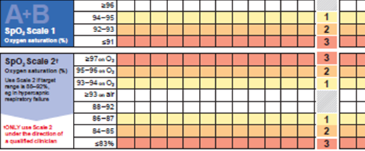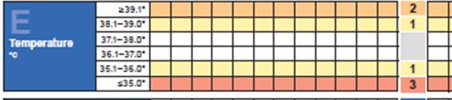

**Increase in score**

* for O2 requirement
* drop in O2 saturation
* Change in HR or BP

**No increase** in score for O2 requirement

Trigger for increase in pyrexia alone

Administer IV paracetamol at appropriate dose & schedule

Re-check eNEWS at

30-60 mins

MAKE **MET** CALL

AS USUAL

Repeat eNEWS in 30-60 mins

eNEWS improving

continue to monitor observations as per protocol

* Increase in O2 requirement
* drop in O2 saturation
* Change in HR or BP
* Score still ≥ 7
* O2 requirements stable

Bleep ward level medical cover for early review

For patients previously identified for full escalation if clinical criteria met in A/B SpO2 scale1 then also contact Rapid Intubation Team via BLEEP 7695