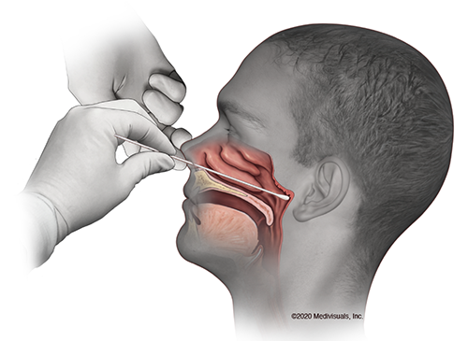**Appropriate samples are** 1) A viral nose swab and a viral throat swab combined into one pot of viral transport medium   
2) Single viral swab used for throat then nose into one pot of viral transport medium or 3) nasopharyngeal aspirate in a universal transport pot.  
*Bacterial or charcoal swabs are not suitable.*Note: if possible send lower respiratory tract sample e.g. sputum or broncho-alveolar lavage (BAL) as sensitivity of detection is greater in these.

**NASOPHARYNX**

**Nasopharyngeal (nose) swab**

Step 1: Tilt patients head back **70⁰**

Step 2: Insert the swab along the floor of the nose **around 8-10cm** until the posterior nasopharynx is reached **STRAIGHT BACK** **-** **NOT UPWARDS**Correct position is shown on the figures to the right.

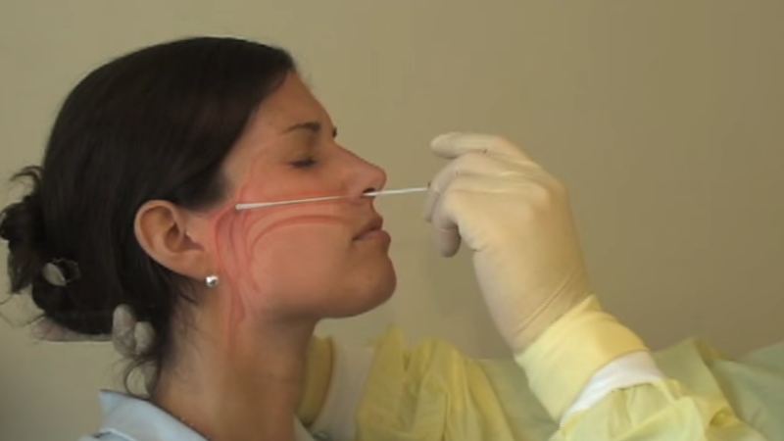The distance should be from the nostril to the outer opening of the ear. Leave swab in place for several seconds to absorb secretions.

Step 3: Slowly remove swab while rotating it.

**Oropharyngeal (throat) swab**

Swab the posterior pharynx, avoiding the tongue.

**GOOD QUALITY** swabs are vital for **DETECTING COVID-19** and preventing **FALSE NEGATIVES**.

Help us keep patients and staff safe.

**Reference:** Coronavirus Disease 2019 (COVID-19) CDC Centres for Disease Control and Prevention https://www.cdc.gov/coronavirus/2019-ncov/lab/guidelines-clinical-specimens.html